**Supplementary Online Material**

**S-1.** Generally, SOEP data are obtained via face-to-face interviews with all members of a household that are 18 years or older. The interviews are based on a set of pretested and validated questionnaires for households and individuals. Households were initially chosen using a multistage random sampling technique with regional clustering; later, some refreshment samples were added to increase sample size and to maintain national representativeness. Goebel et al. (2019) provide comprehensive information about data collection, design, participants, variables, and assessment procedures.

**S-2.** To ensure high precision in our final meta-analytical results we estimated the standard errors using non-parametric bootstrapping techniques on a total of 5,000 bootstrapped samples. In addition, we ran several sensitivity analyses on the meta-analytical results. Specifically, we checked the robustness of the meta-analytical (omnibus) and meta-regression (cultural religiosity as moderator) effects for the exclusion of any federal state. By showing that the results hold after excluding any federal state from the analysis, we ensured that the results were not purely driven by one particular outlier state and that the estimated results hold more generally. To run this sensitivity analysis, we replicated all meta-analyses and meta-regressions in 14 extra specifications in which one federal state was left out at a time. Online Supplement S-2a through S-2d contain the results of these additional analyses. Specifically, S-2a contains the sensitivity analyses for the main text’s Table 2 omnibus (i.e., meta-analysis) and cultural religiosity as moderator (i.e., meta-regression) results for the cross-lagged effects from religiosity on the Big Five traits. S-2b contains the sensitivity analyses for the main text’s Table 3 omnibus and cultural religiosity as moderator results for the cross-lagged effects from the Big Five traits on religiosity. S-2c contains the sensitivity analyses for the omnibus results on the stability effects presented in Table S-5a. S-2d, finally, contains the sensitivity analyses for the omnibus and cultural religiosity as moderator results on correlated change between the Big Five traits and religiosity presented in Table S-5b. In each figure, the x-axis indicates which federal state is left out in each of the sensitivity analyses with the overall result as a reference (labelled “none”). The figures show that there was no major outlier driving our overall effects. Thus, the results were robust against the exclusion of any federal state from the analysis.

**S-2a****.** The following figures display the results from the sensitivity analyses for the cross-lagged effects from religiosity on the Big Five personality traits (Table 2).

**Omnibus effects**

Figure S-2a.1

*Sensitivity Analysis of the Omnibus Cross-Lagged Effect From Religiosity on Agreeableness*

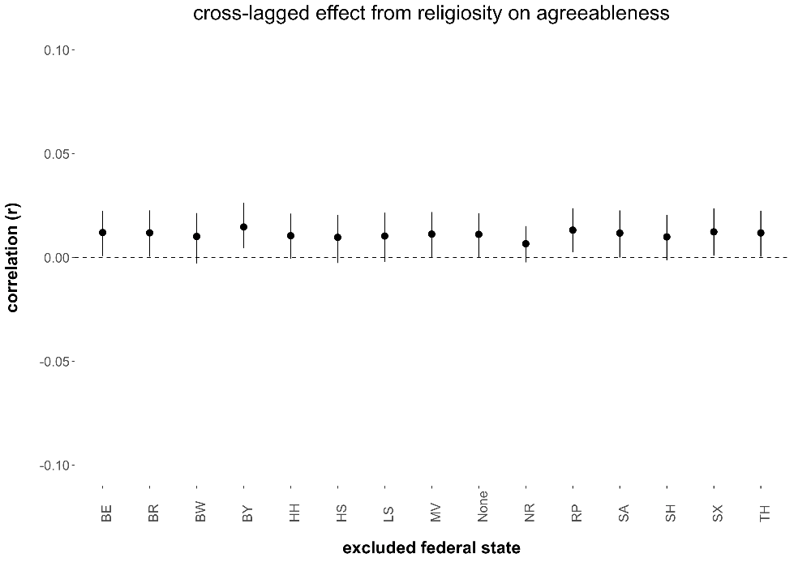

*Note.* The figure displays the point estimates and associated 95 percent confidence intervals (black vertical lines) of the omnibus cross-lagged effect from religiosity on agreeableness estimated when excluding a particular federal state from the meta-analysis. MV = Mecklenburg-Vorpommern, SA = Saxony-Anhalt, BR = Brandenburg, SX = Saxony, BL = Berlin, TH = Thuringia, HH = Hamburg, SH = Schleswig-Holstein, LS = Lower-Saxony, HS = Hesse, NR = North Rhine – Westphalia, RP = Rhineland-Palatinate, BW = Baden-Württemberg, BA = Bavaria.

Figure S-2a.2

*Sensitivity Analysis of the Omnibus Cross-Lagged Effect From Religiosity on Openness*

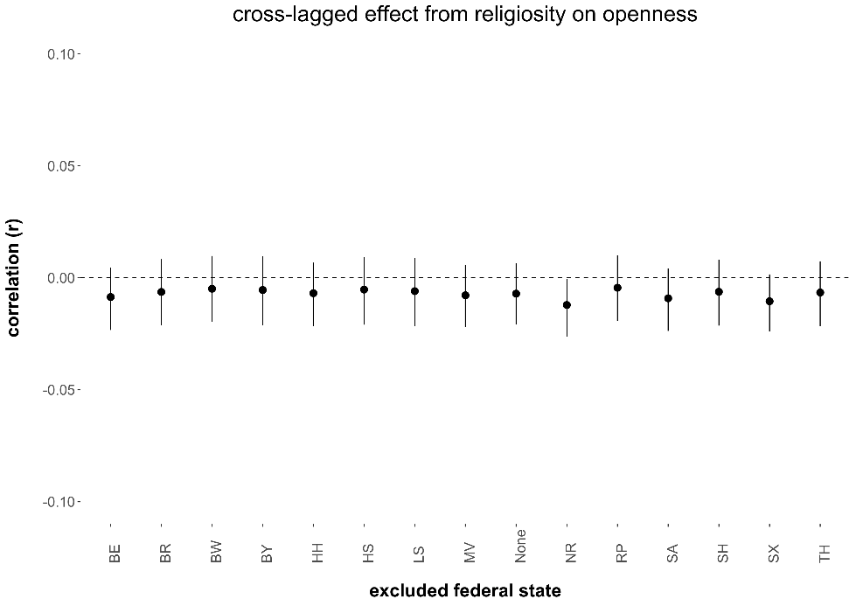

*Note.* The figure displays the point estimates and associated 95 percent confidence intervals (black vertical lines) of the omnibus cross-lagged effect from religiosity on openness estimated when excluding a particular federal state from the meta-analysis. MV = Mecklenburg-Vorpommern, SA = Saxony-Anhalt, BR = Brandenburg, SX = Saxony, BL = Berlin, TH = Thuringia, HH = Hamburg, SH = Schleswig-Holstein, LS = Lower-Saxony, HS = Hesse, NR = North Rhine – Westphalia, RP = Rhineland-Palatinate, BW = Baden-Württemberg, BA = Bavaria.

Figure S-2a.3

*Sensitivity Analysis of the Omnibus Cross-Lagged Effect From Religiosity on Conscientiousness*

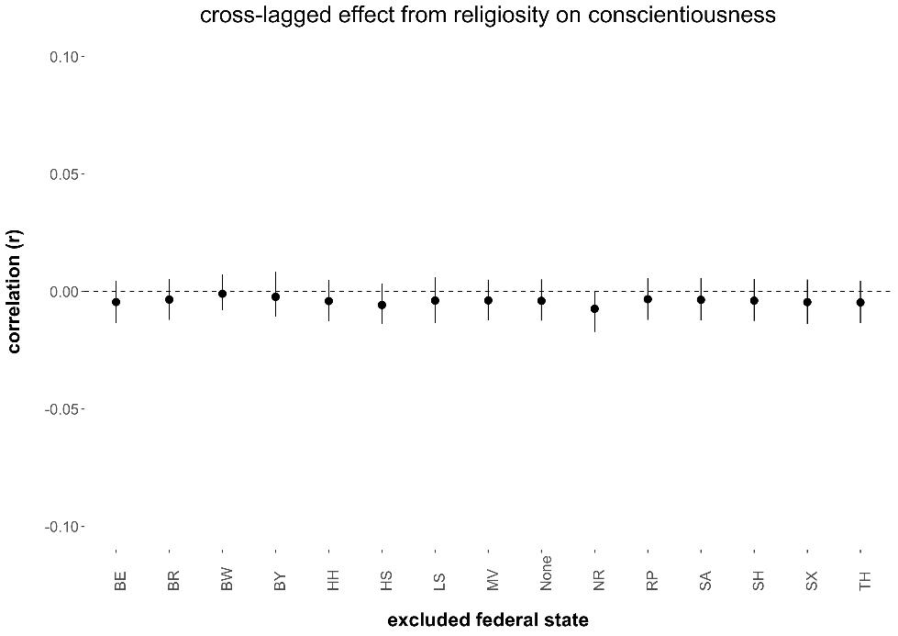

*Note.* The figure displays the point estimates and associated 95 percent confidence intervals (black vertical lines) of the omnibus cross-lagged effect from religiosity on conscientiousness estimated when excluding a particular federal state from the meta-analysis. MV = Mecklenburg-Vorpommern, SA = Saxony-Anhalt, BR = Brandenburg, SX = Saxony, BL = Berlin, TH = Thuringia, HH = Hamburg, SH = Schleswig-Holstein, LS = Lower-Saxony, HS = Hesse, NR = North Rhine – Westphalia, RP = Rhineland-Palatinate, BW = Baden-Württemberg, BA = Bavaria.

Figure S-2a.4

*Sensitivity Analysis of the Omnibus Cross-Lagged Effect From Religiosity on Extraversion*

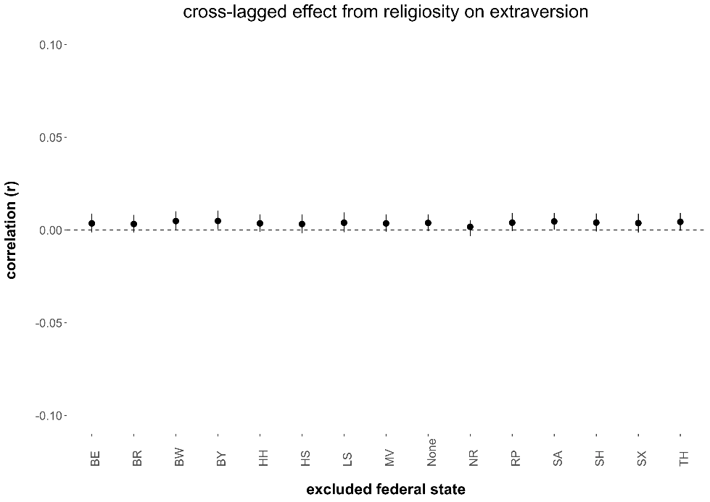

*Note.* The figure displays the point estimates and associated 95 percent confidence intervals (black vertical lines) of the omnibus cross-lagged effect from religiosity on extraversion estimated when excluding a particular federal state from the meta-analysis. MV = Mecklenburg-Vorpommern, SA = Saxony-Anhalt, BR = Brandenburg, SX = Saxony, BL = Berlin, TH = Thuringia, HH = Hamburg, SH = Schleswig-Holstein, LS = Lower-Saxony, HS = Hesse, NR = North Rhine – Westphalia, RP = Rhineland-Palatinate, BW = Baden-Württemberg, BA = Bavaria.

Figure S-2a.5

*Sensitivity Analysis of the Omnibus Cross-Lagged Effect From Religiosity on Neuroticism*

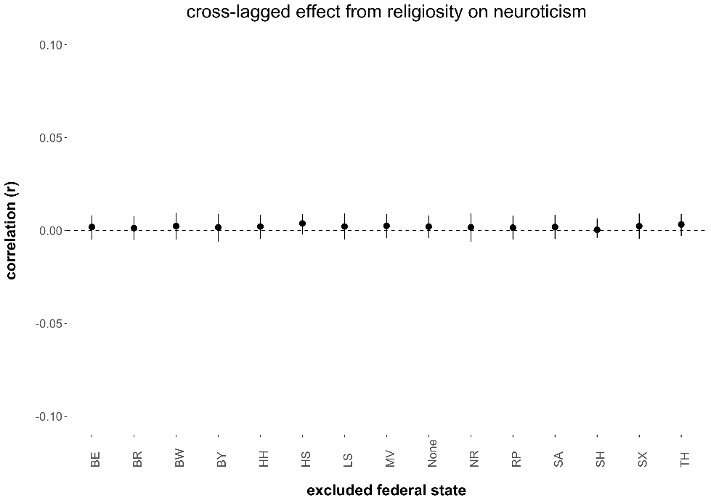

*Note.* The figure displays the point estimates and associated 95 percent confidence intervals (black vertical lines) of the omnibus cross-lagged effect from religiosity on neuroticism estimated when excluding a particular federal state from the meta-analysis. MV = Mecklenburg-Vorpommern, SA = Saxony-Anhalt, BR = Brandenburg, SX = Saxony, BL = Berlin, TH = Thuringia, HH = Hamburg, SH = Schleswig-Holstein, LS = Lower-Saxony, HS = Hesse, NR = North Rhine – Westphalia, RP = Rhineland-Palatinate, BW = Baden-Württemberg, BA = Bavaria.

**Cultural Religiosity as Moderator Effects**

Figure S-2a.6

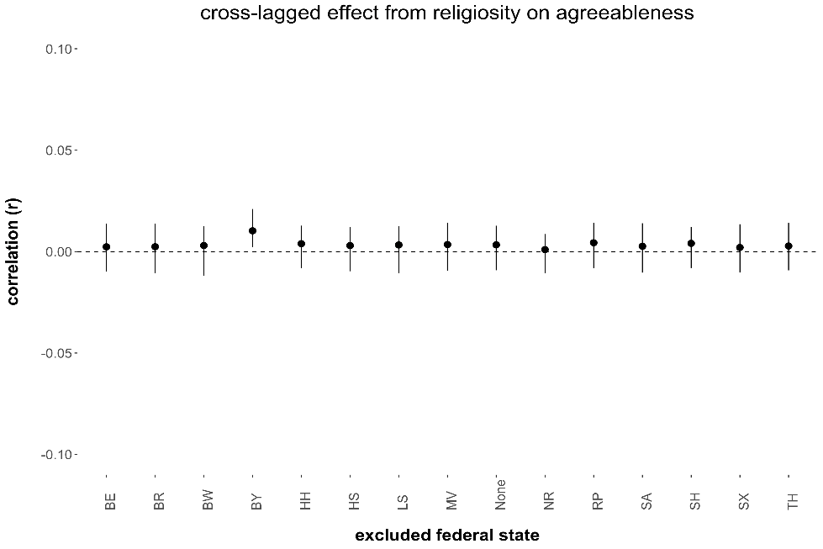*Sensitivity Analysis for the Cultural Religiosity as Moderator Cross-Lagged Effect From Religiosity on Agreeableness*

*Note.* The figure displays the point estimates and associated 95 percent confidence intervals (black vertical lines) of the cultural religiosity as moderator cross-lagged effect from religiosity on agreeableness estimated when excluding a particular federal state from the meta-regression. MV = Mecklenburg-Vorpommern, SA = Saxony-Anhalt, BR = Brandenburg, SX = Saxony, BL = Berlin, TH = Thuringia, HH = Hamburg, SH = Schleswig-Holstein, LS = Lower-Saxony, HS = Hesse, NR = North Rhine – Westphalia, RP = Rhineland-Palatinate, BW = Baden-Württemberg, BA = Bavaria.

Figure S-2a.7

*Sensitivity Analysis for the Cultural Religiosity as Moderator Cross-Lagged Effect From Religiosity on Openness*

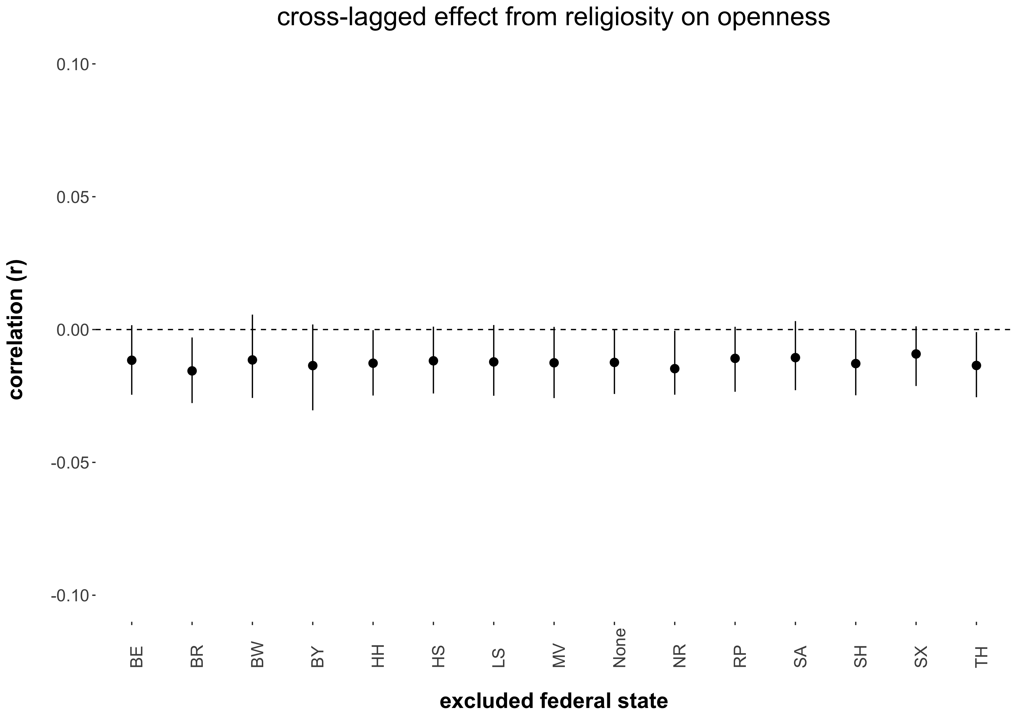

*Note.* The figure displays the point estimates and associated 95 percent confidence intervals (black vertical lines) of the cultural religiosity as moderator cross-lagged effect from religiosity on openness estimated when excluding a particular federal state from the meta-regression. MV = Mecklenburg-Vorpommern, SA = Saxony-Anhalt, BR = Brandenburg, SX = Saxony, BL = Berlin, TH = Thuringia, HH = Hamburg, SH = Schleswig-Holstein, LS = Lower-Saxony, HS = Hesse, NR = North Rhine – Westphalia, RP = Rhineland-Palatinate, BW = Baden-Württemberg, BA = Bavaria.

Figure S-2a.8

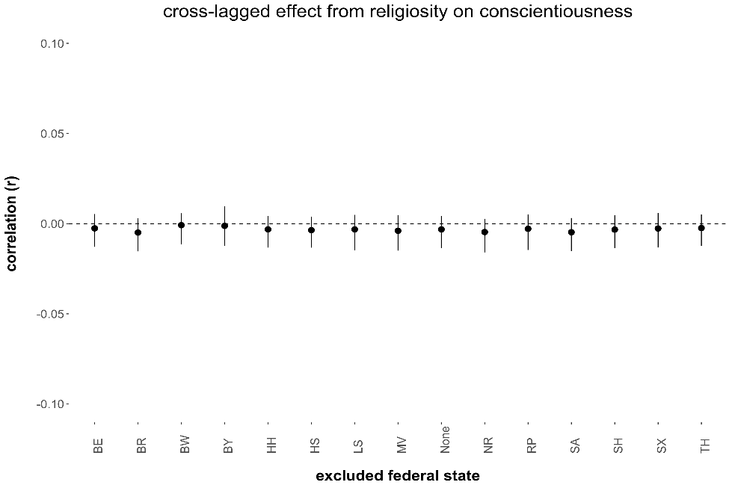*Sensitivity Analysis for the Cultural Religiosity as Moderator Cross-Lagged Effect From Religiosity on Conscientiousness*

*Note.* The figure displays the point estimates and associated 95 percent confidence intervals (black vertical lines) of the cultural religiosity as moderator cross-lagged effect from religiosity on conscientiousness estimated when excluding a particular federal state from the meta-regression. MV = Mecklenburg-Vorpommern, SA = Saxony-Anhalt, BR = Brandenburg, SX = Saxony, BL = Berlin, TH = Thuringia, HH = Hamburg, SH = Schleswig-Holstein, LS = Lower-Saxony, HS = Hesse, NR = North Rhine – Westphalia, RP = Rhineland-Palatinate, BW = Baden-Württemberg, BA = Bavaria.

Figure S-2a.9

*Sensitivity Analysis for the Cultural Religiosity as Moderator Cross-Lagged Effect From Religiosity on Extraversion*

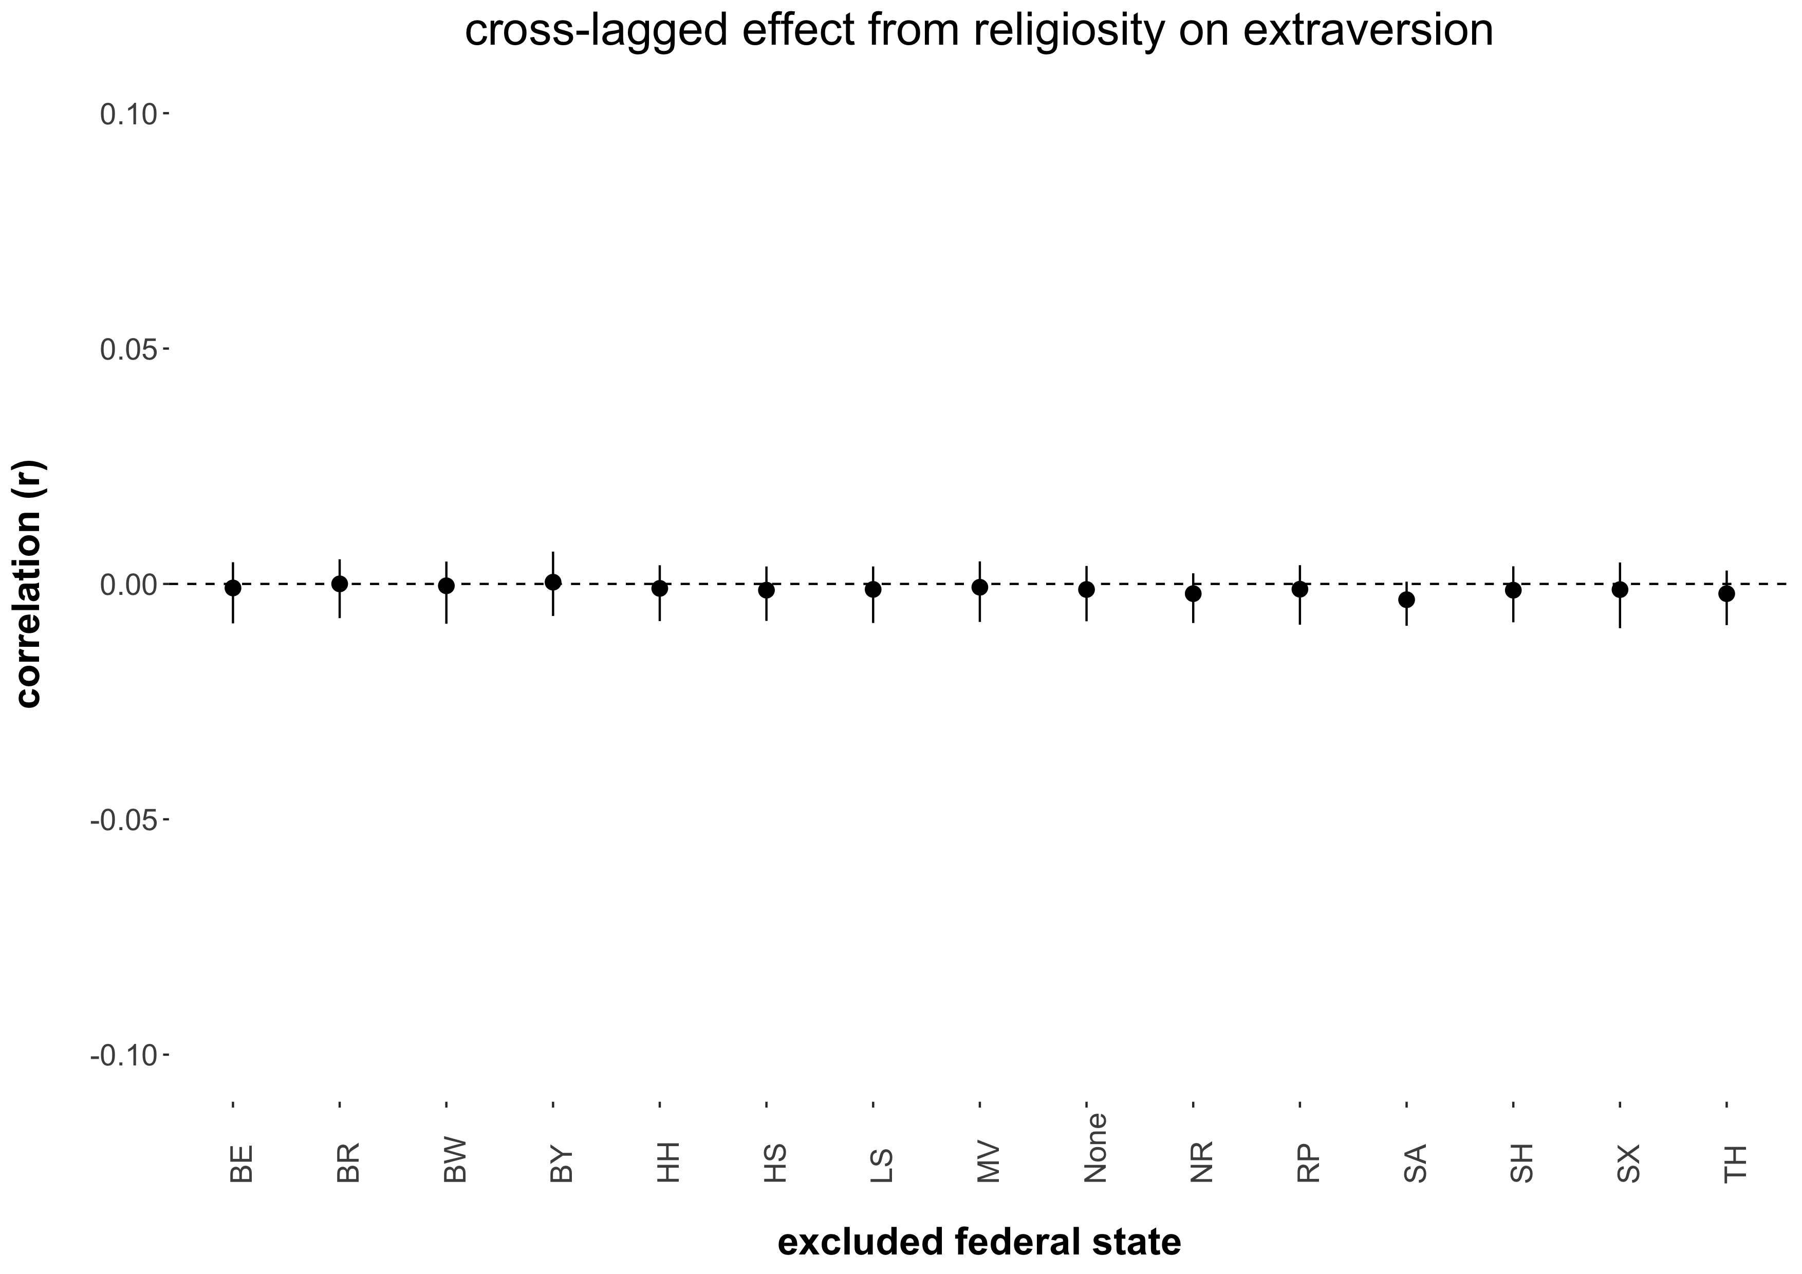

*Note.* The figure displays the point estimates and associated 95 percent confidence intervals (black vertical lines) of the cultural religiosity as moderator cross-lagged effect from religiosity on extraversion estimated when excluding a particular federal state from the meta-regression. MV = Mecklenburg-Vorpommern, SA = Saxony-Anhalt, BR = Brandenburg, SX = Saxony, BL = Berlin, TH = Thuringia, HH = Hamburg, SH = Schleswig-Holstein, LS = Lower-Saxony, HS = Hesse, NR = North Rhine – Westphalia, RP = Rhineland-Palatinate, BW = Baden-Württemberg, BA = Bavaria.

Figure S-2a.10

*Sensitivity Analysis for the Cultural Religiosity as Moderator Cross-Lagged Effect From Religiosity on Neuroticism*

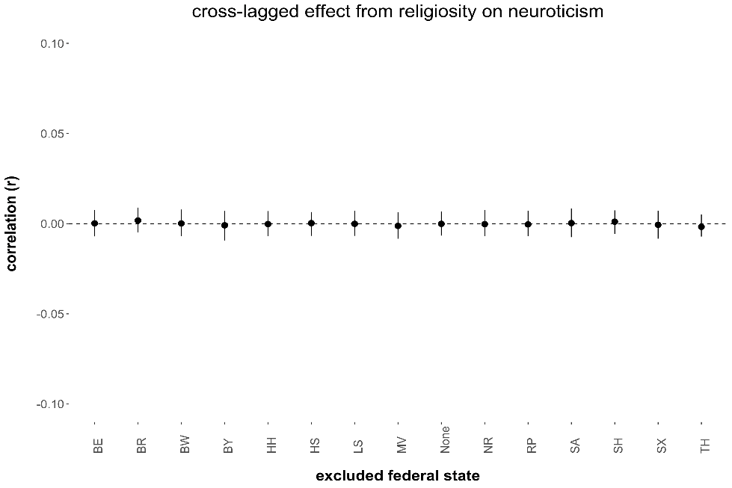

*Note.* The figure displays the point estimates and associated 95 percent confidence intervals (black vertical lines) of the cultural religiosity as moderator cross-lagged effect from religiosity on neuroticism estimated when excluding a particular federal state from the meta-regression. MV = Mecklenburg-Vorpommern, SA = Saxony-Anhalt, BR = Brandenburg, SX = Saxony, BL = Berlin, TH = Thuringia, HH = Hamburg, SH = Schleswig-Holstein, LS = Lower-Saxony, HS = Hesse, NR = North Rhine – Westphalia, RP = Rhineland-Palatinate, BW = Baden-Württemberg, BA = Bavaria.

**S-2b.** The following figures display the results from the sensitivity analyses for the cross-lagged effects from the Big Five personality traits on religiosity (Table 3).

**Omnibus effects**

Figure S-2b.1

*Sensitivity Analysis of the Omnibus Cross-Lagged Effect From Agreeableness on Religiosity*

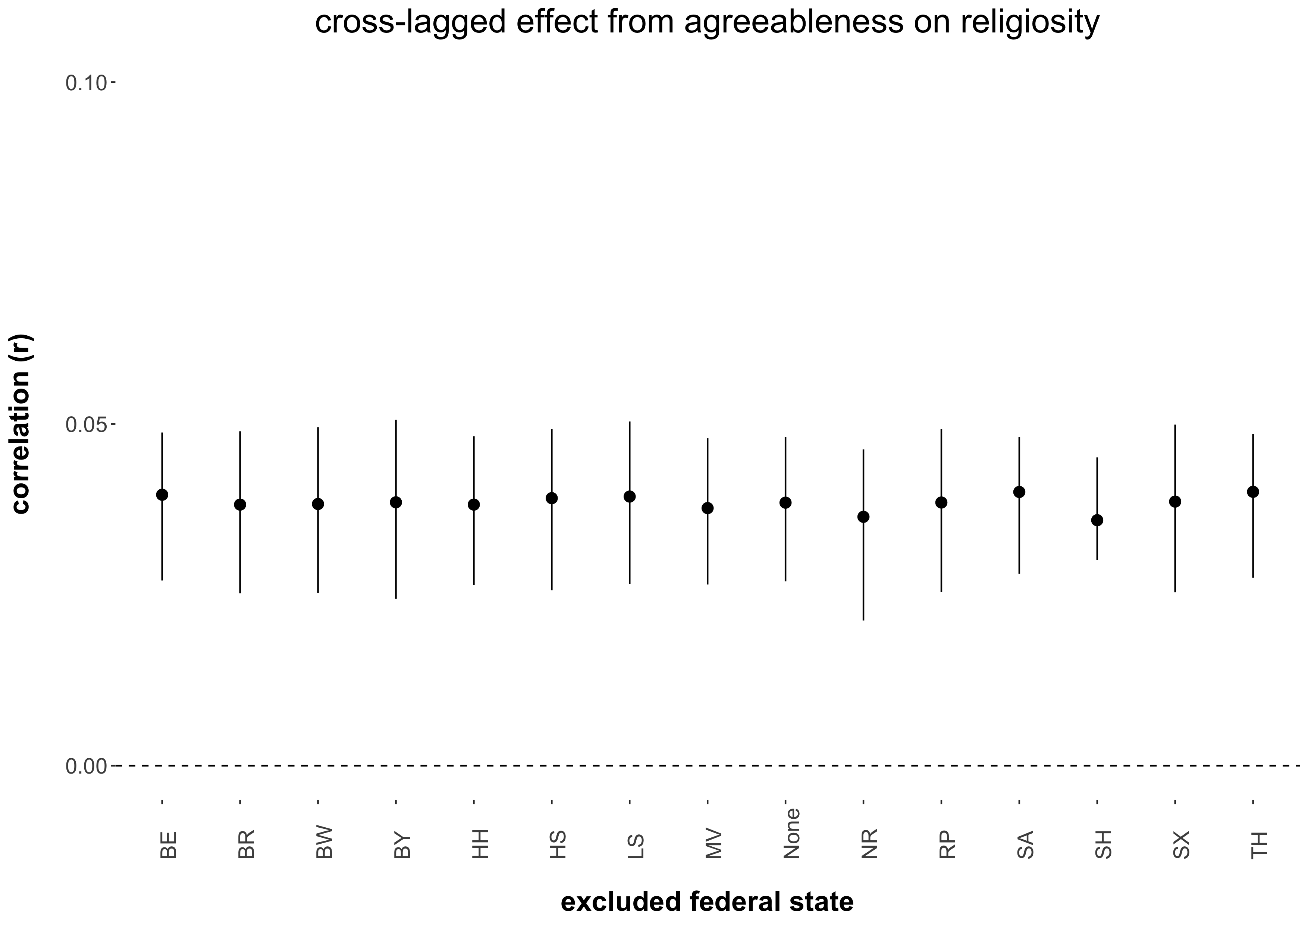

*Note.* The figure displays the point estimates and associated 95 percent confidence intervals (black vertical lines) of the omnibus cross-lagged effect from agreeableness on religiosity estimated when excluding a particular federal state from the meta-analysis. MV = Mecklenburg-Vorpommern, SA = Saxony-Anhalt, BR = Brandenburg, SX = Saxony, BL = Berlin, TH = Thuringia, HH = Hamburg, SH = Schleswig-Holstein, LS = Lower-Saxony, HS = Hesse, NR = North Rhine – Westphalia, RP = Rhineland-Palatinate, BW = Baden-Württemberg, BA = Bavaria.

Figure S-2b.2

*Sensitivity Analysis of the Omnibus Cross-Lagged Effect From Openness on Religiosity*

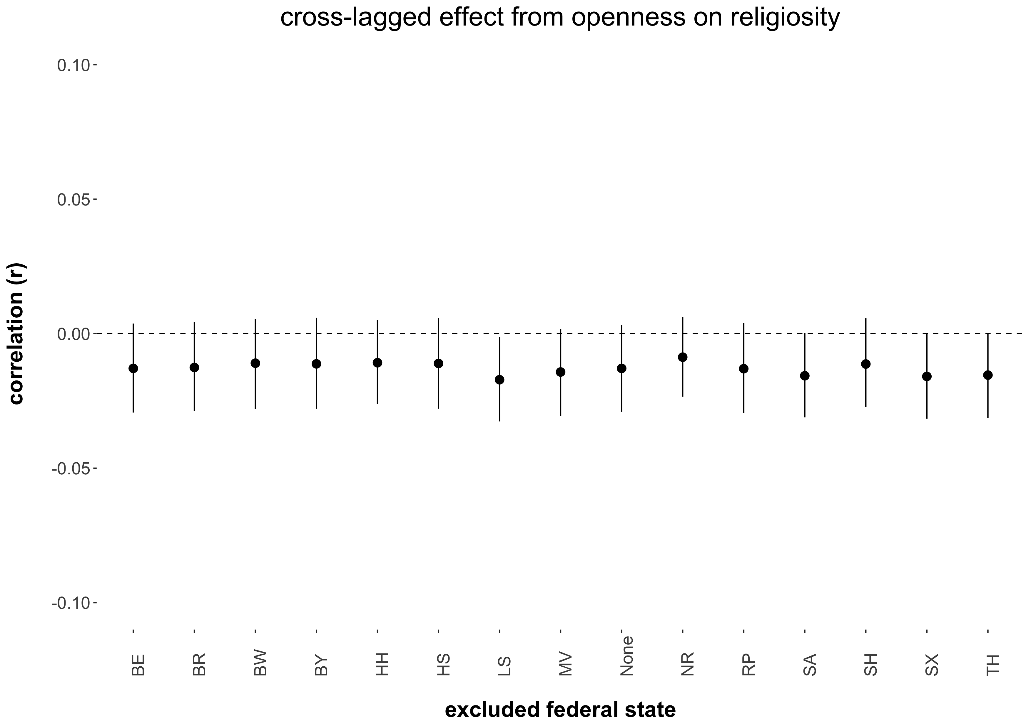

*Note.* The figure displays the point estimates and associated 95 percent confidence intervals (black vertical lines) of the omnibus cross-lagged effect from openness on religiosity estimated when excluding a particular federal state from the meta-analysis. MV = Mecklenburg-Vorpommern, SA = Saxony-Anhalt, BR = Brandenburg, SX = Saxony, BL = Berlin, TH = Thuringia, HH = Hamburg, SH = Schleswig-Holstein, LS = Lower-Saxony, HS = Hesse, NR = North Rhine – Westphalia, RP = Rhineland-Palatinate, BW = Baden-Württemberg, BA = Bavaria.

Figure S-2b.3

*Sensitivity Analysis of the Omnibus Cross-Lagged Effect From Conscientiousness on Religiosity*

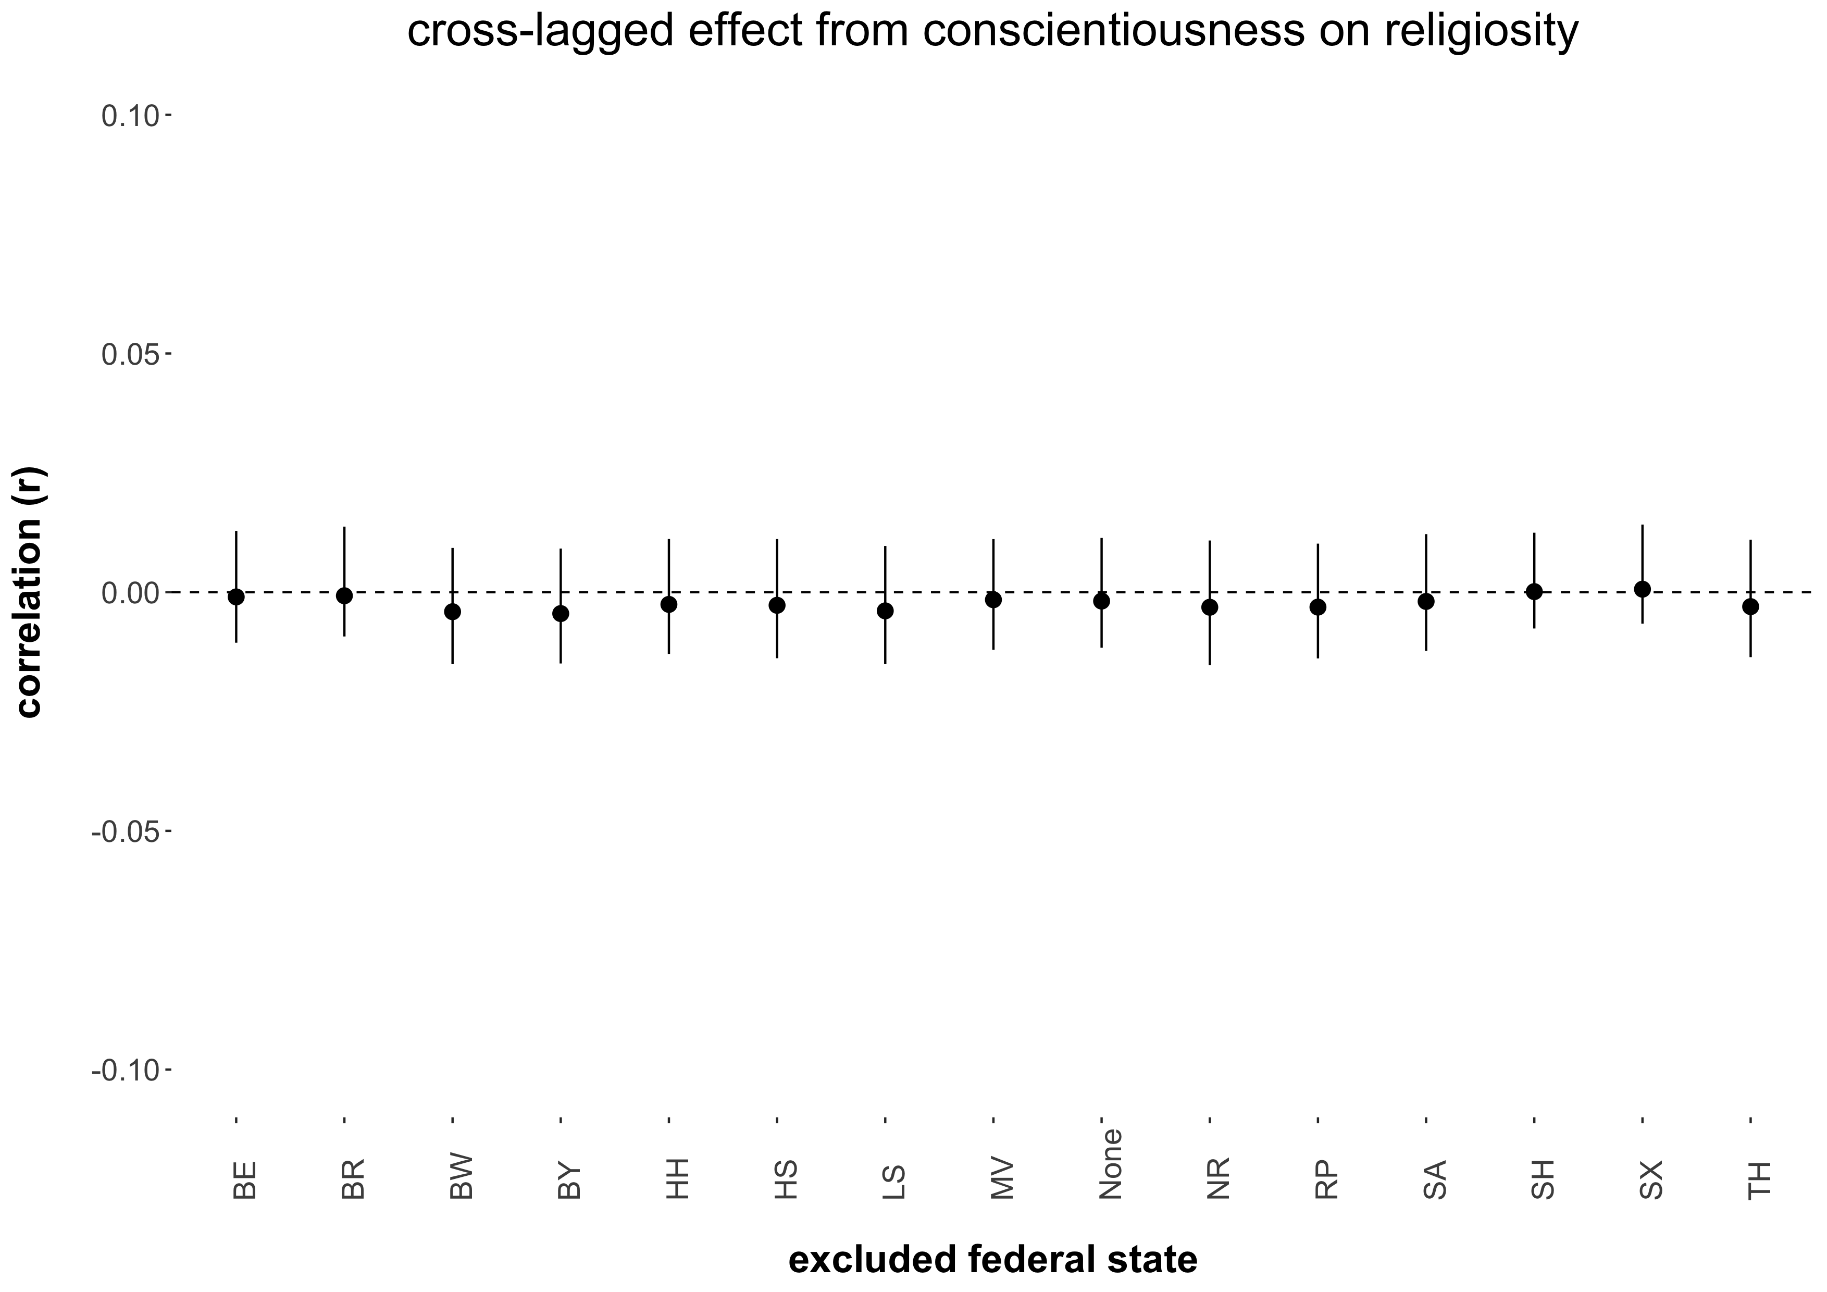

*Note.* The figure displays the point estimates and associated 95 percent confidence intervals (black vertical lines) of the omnibus cross-lagged effect from conscientiousness on religiosity estimated when excluding a particular federal state from the meta-analysis. MV = Mecklenburg-Vorpommern, SA = Saxony-Anhalt, BR = Brandenburg, SX = Saxony, BL = Berlin, TH = Thuringia, HH = Hamburg, SH = Schleswig-Holstein, LS = Lower-Saxony, HS = Hesse, NR = North Rhine – Westphalia, RP = Rhineland-Palatinate, BW = Baden-Württemberg, BA = Bavaria.

Figure S-2b.4

*Sensitivity Analysis of the Omnibus Cross-Lagged Effect From Extraversion on Religiosity*

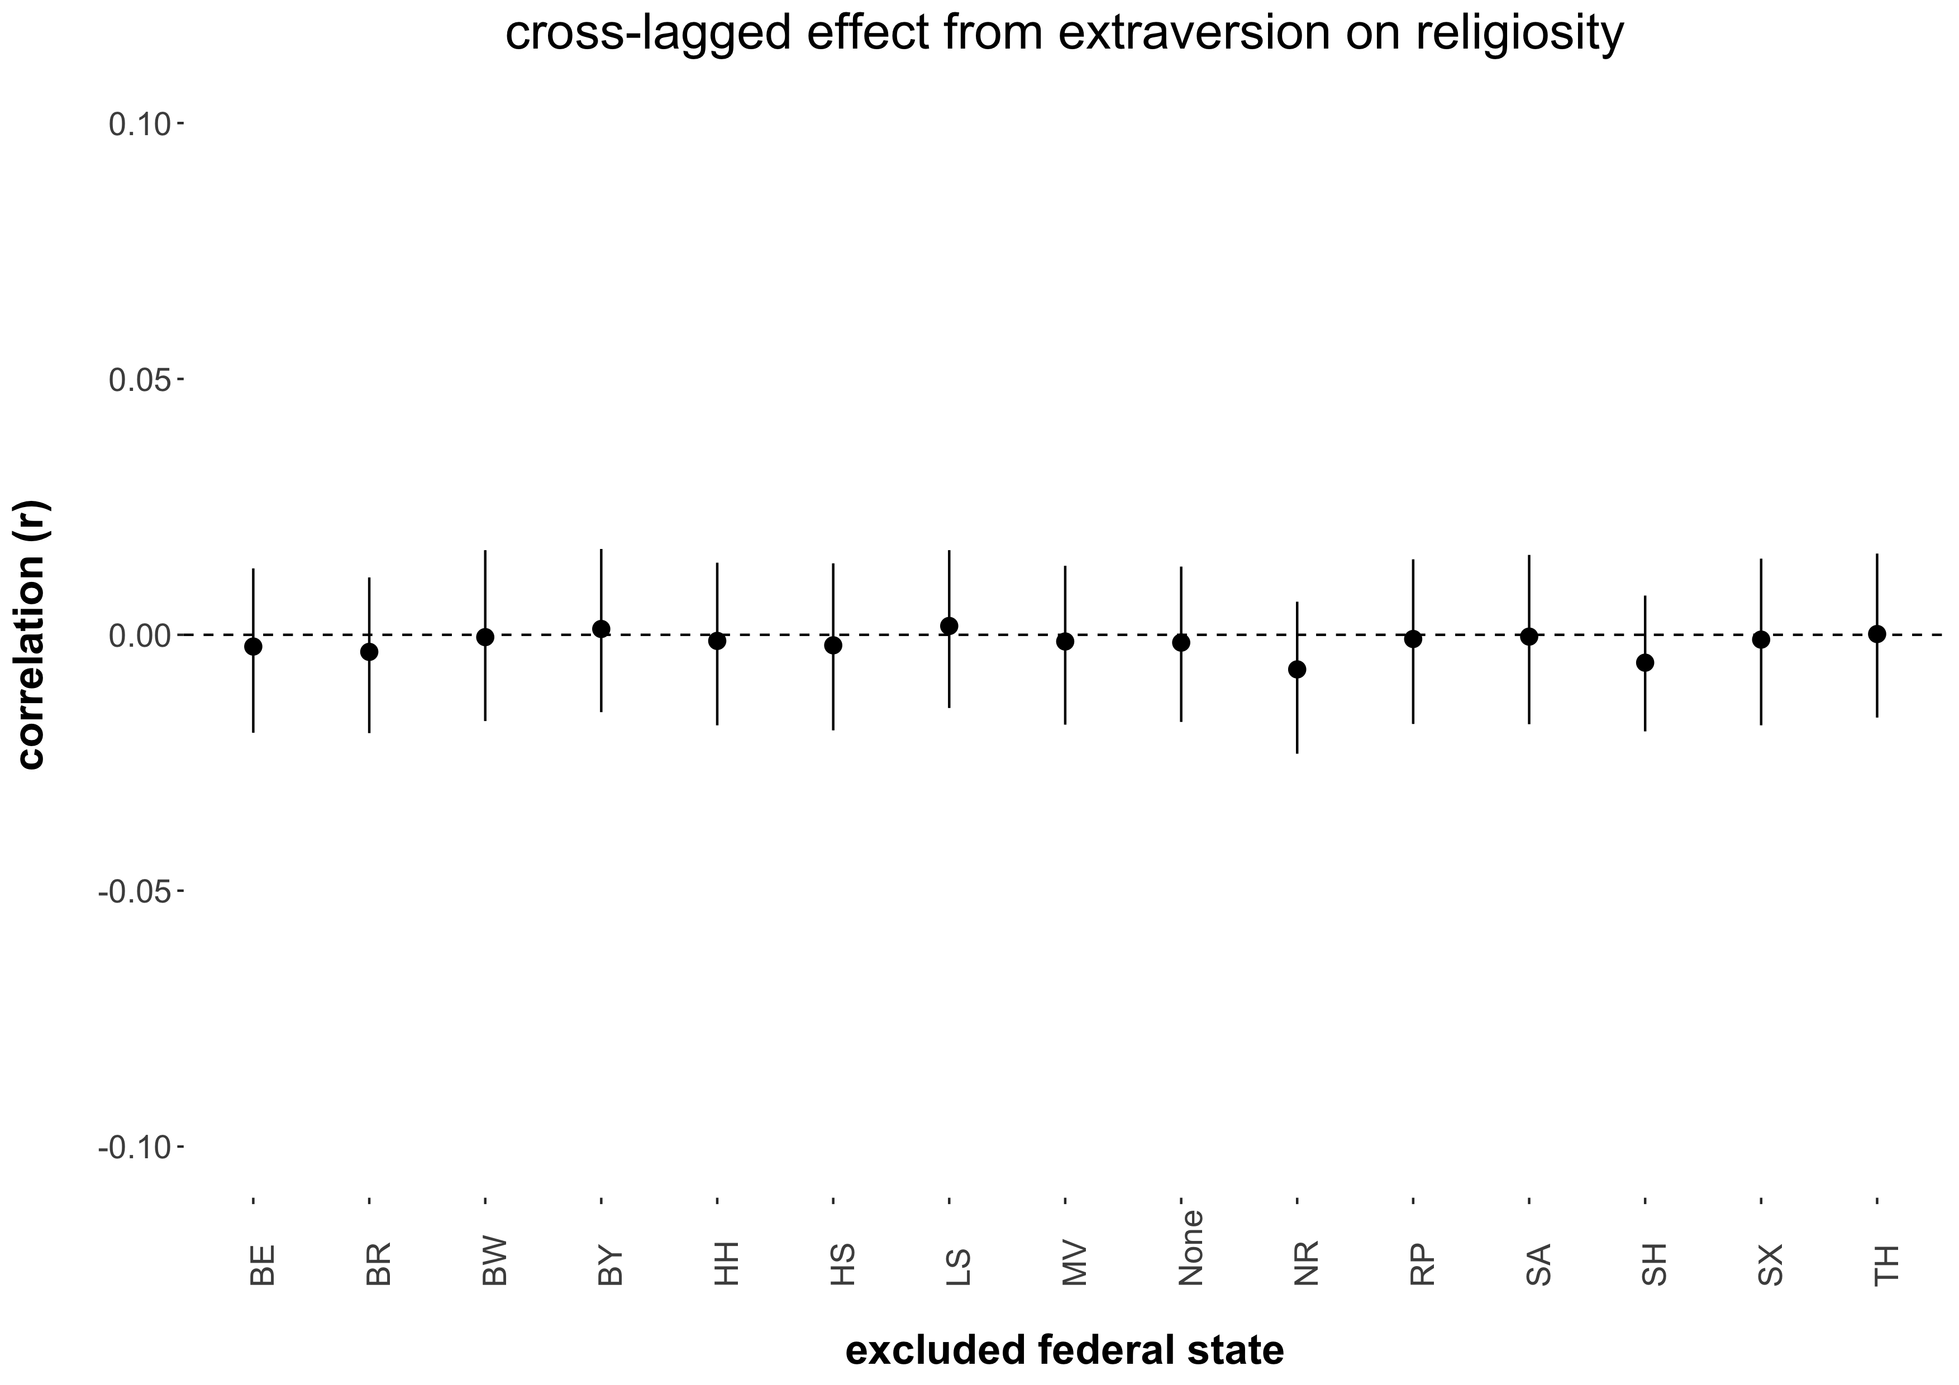

*Note.* The figure displays the point estimates and associated 95 percent confidence intervals (black vertical lines) of the omnibus cross-lagged effect from extraversion on religiosity estimated when excluding a particular federal state from the meta-analysis. MV = Mecklenburg-Vorpommern, SA = Saxony-Anhalt, BR = Brandenburg, SX = Saxony, BL = Berlin, TH = Thuringia, HH = Hamburg, SH = Schleswig-Holstein, LS = Lower-Saxony, HS = Hesse, NR = North Rhine – Westphalia, RP = Rhineland-Palatinate, BW = Baden-Württemberg, BA = Bavaria.

Figure S-2b.5

*Sensitivity Analysis of the Omnibus Cross-Lagged Effect From Neuroticism on Religiosity*

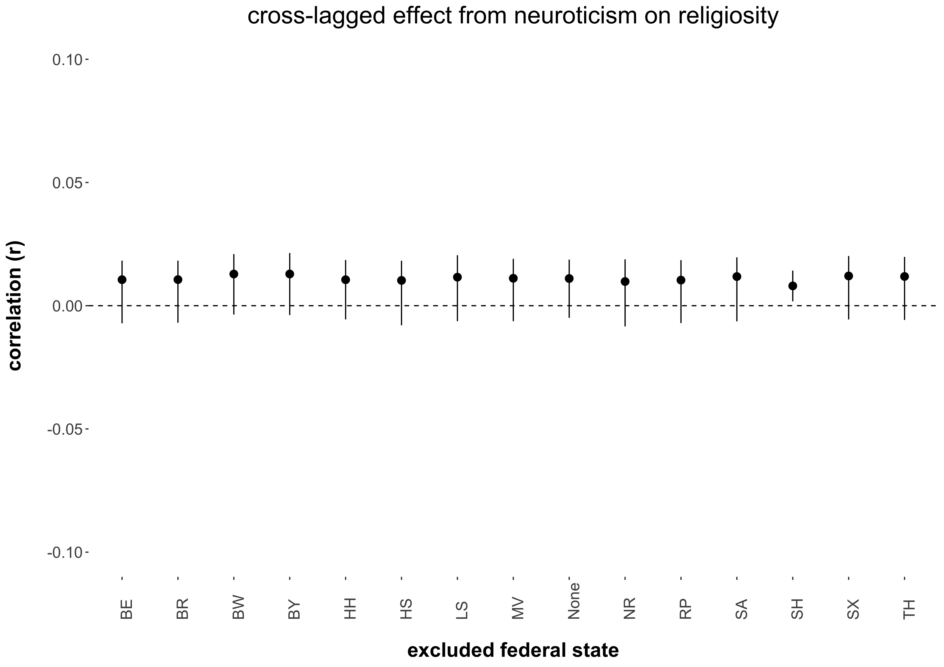

*Note.* The figure displays the point estimates and associated 95 percent confidence intervals (black vertical lines) of the omnibus cross-lagged effect from neuroticism on religiosity estimated when excluding a particular federal state from the meta-analysis. MV = Mecklenburg-Vorpommern, SA = Saxony-Anhalt, BR = Brandenburg, SX = Saxony, BL = Berlin, TH = Thuringia, HH = Hamburg, SH = Schleswig-Holstein, LS = Lower-Saxony, HS = Hesse, NR = North Rhine – Westphalia, RP = Rhineland-Palatinate, BW = Baden-Württemberg, BA = Bavaria.

**Cultural Religiosity as Moderator Effects**

Figure S-2b.6

*Sensitivity Analysis for the Cultural Religiosity as Moderator Cross-Lagged Effect From Agreeableness on Religiosity*

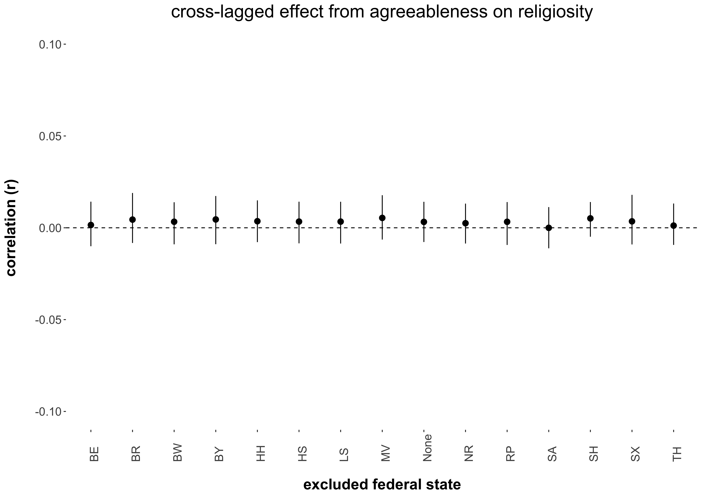

*Note.* The figure displays the point estimates and associated 95 percent confidence intervals (black vertical lines) of the cultural religiosity as moderator cross-lagged effect from agreeableness on religiosity estimated when excluding a particular federal state from the meta-regression. MV = Mecklenburg-Vorpommern, SA = Saxony-Anhalt, BR = Brandenburg, SX = Saxony, BL = Berlin, TH = Thuringia, HH = Hamburg, SH = Schleswig-Holstein, LS = Lower-Saxony, HS = Hesse, NR = North Rhine – Westphalia, RP = Rhineland-Palatinate, BW = Baden-Württemberg, BA = Bavaria.

Figure S-2b.7

*Sensitivity Analysis for the Cultural Religiosity as Moderator Cross-Lagged Effect From Openness on Religiosity*

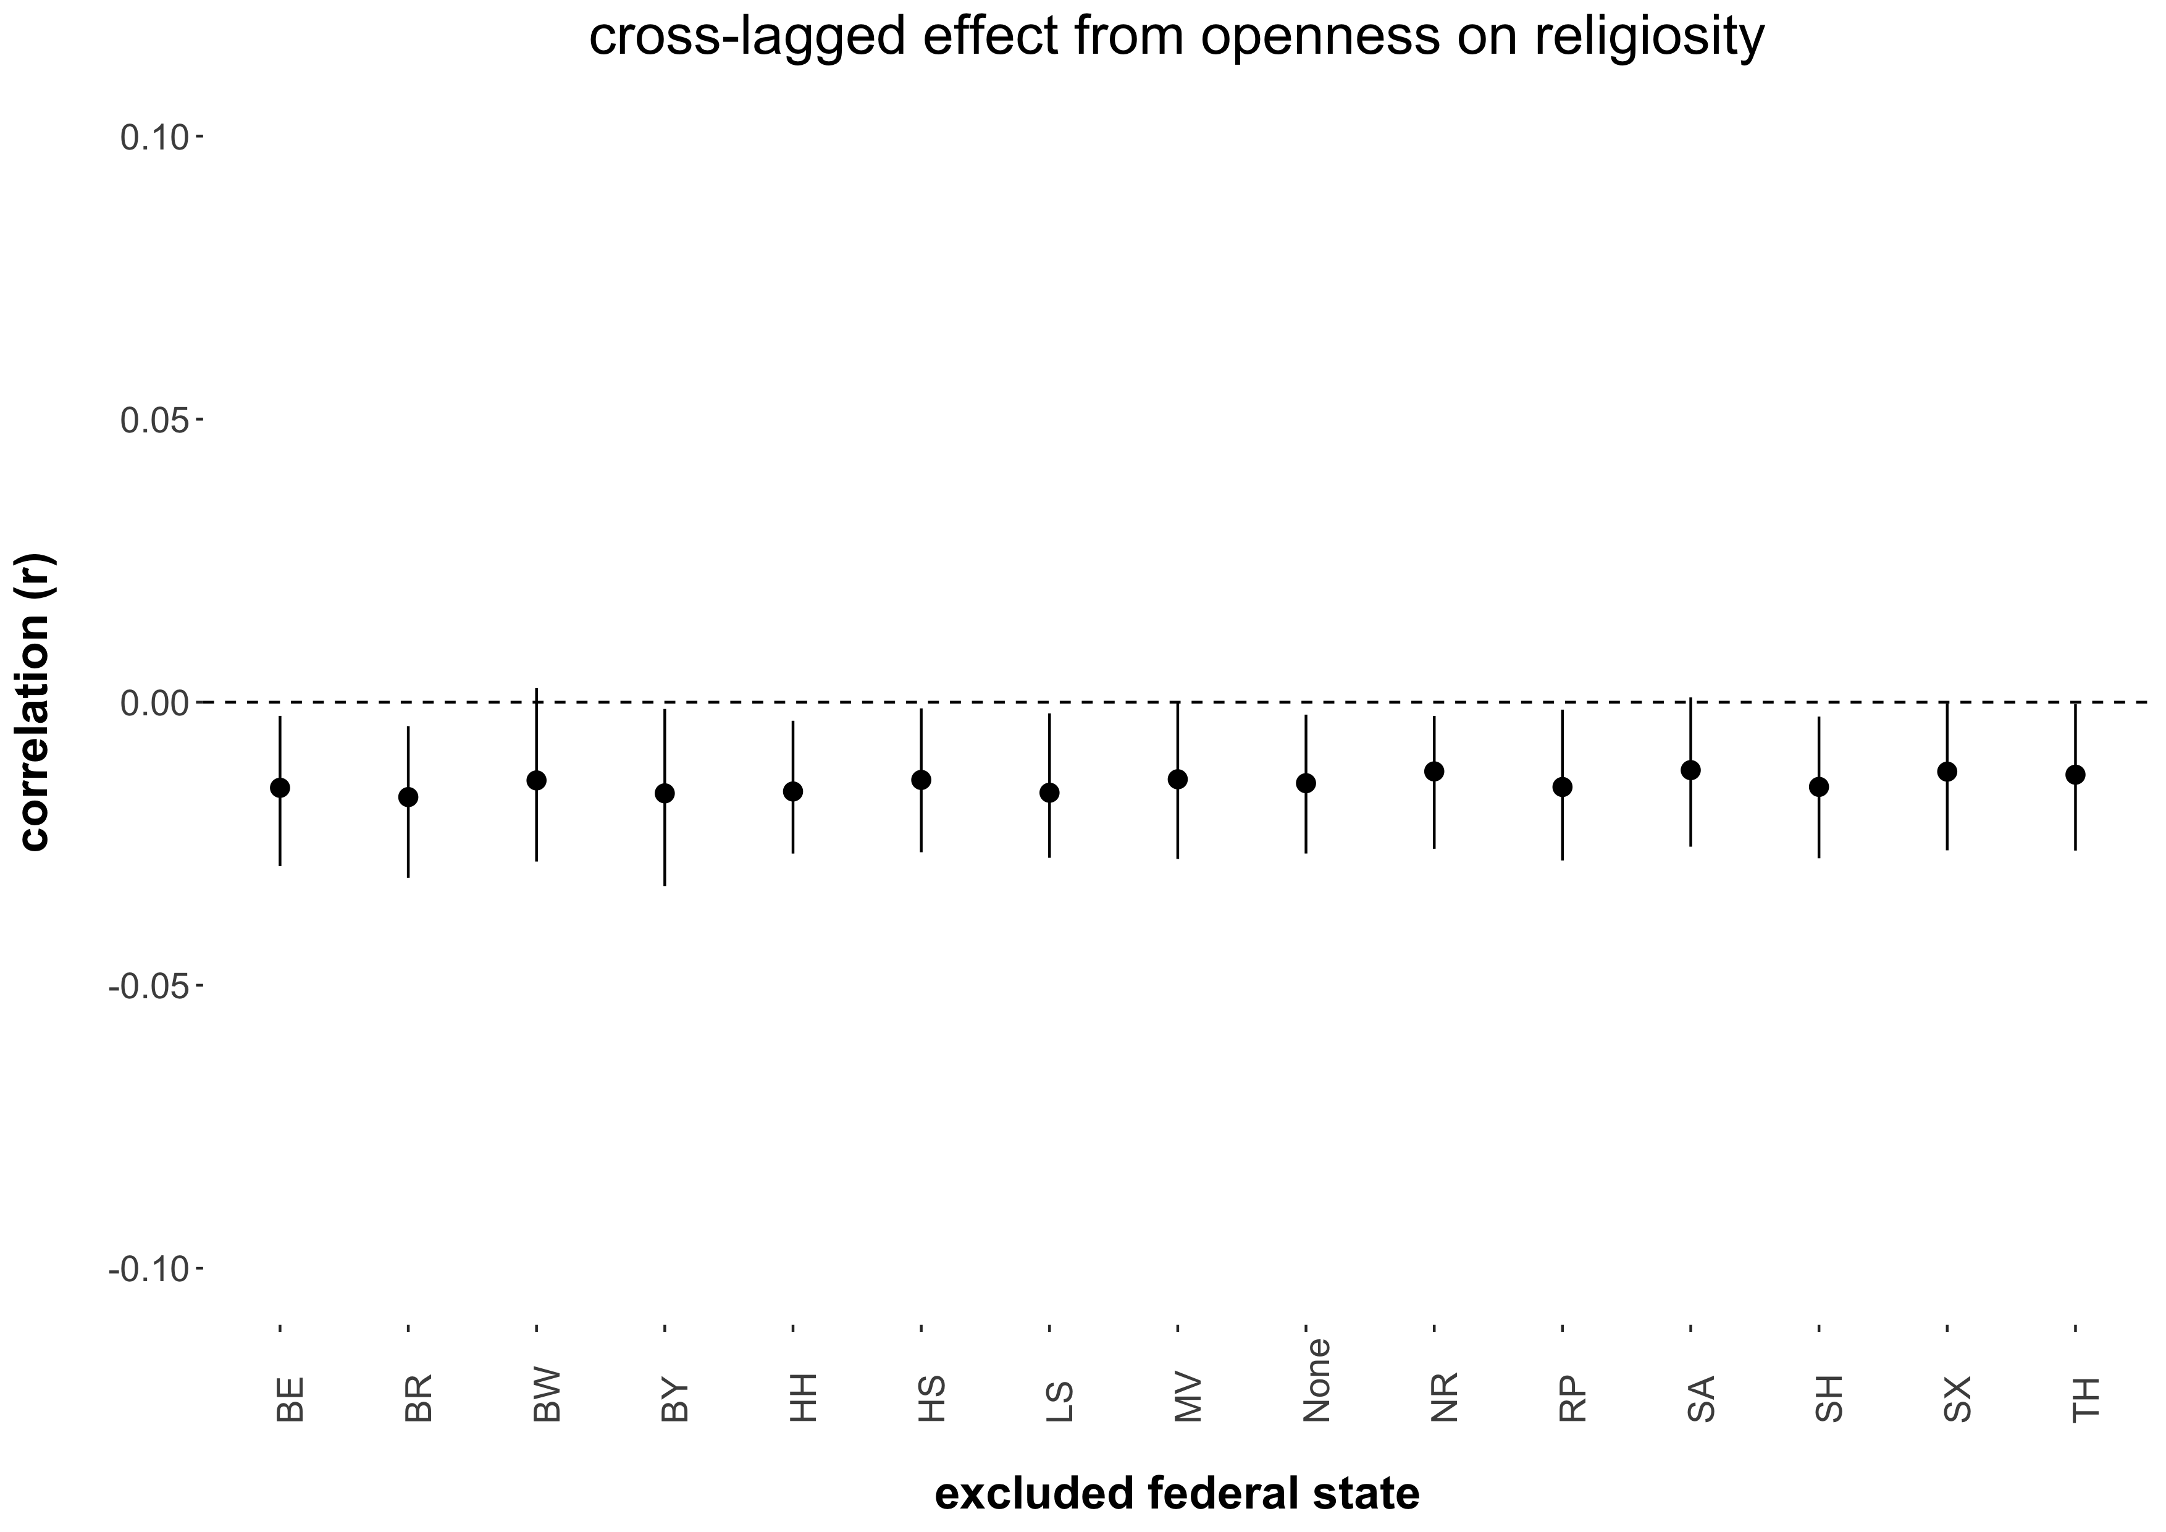

*Note.* The figure displays the point estimates and associated 95 percent confidence intervals (black vertical lines) of the cultural religiosity as moderator cross-lagged effect from openness on religiosity estimated when excluding a particular federal state from the meta-regression. MV = Mecklenburg-Vorpommern, SA = Saxony-Anhalt, BR = Brandenburg, SX = Saxony, BL = Berlin, TH = Thuringia, HH = Hamburg, SH = Schleswig-Holstein, LS = Lower-Saxony, HS = Hesse, NR = North Rhine – Westphalia, RP = Rhineland-Palatinate, BW = Baden-Württemberg, BA = Bavaria.

Figure S-2b.8

*Sensitivity Analysis for the Cultural Religiosity as Moderator Cross-Lagged Effect From Conscientiousness on Religiosity*

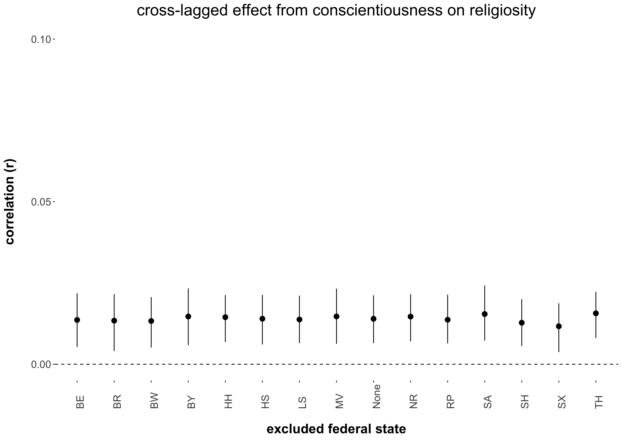

*Note.* The figure displays the point estimates and associated 95 percent confidence intervals (black vertical lines) of the cultural religiosity as moderator cross-lagged effect from conscientiousness on religiosity estimated when excluding a particular federal state from the meta-regression. MV = Mecklenburg-Vorpommern, SA = Saxony-Anhalt, BR = Brandenburg, SX = Saxony, BL = Berlin, TH = Thuringia, HH = Hamburg, SH = Schleswig-Holstein, LS = Lower-Saxony, HS = Hesse, NR = North Rhine – Westphalia, RP = Rhineland-Palatinate, BW = Baden-Württemberg, BA = Bavaria.

Figure S-2b.9

*Sensitivity Analysis for the Cultural Religiosity as Moderator Cross-Lagged Effect From Extraversion on Religiosity*

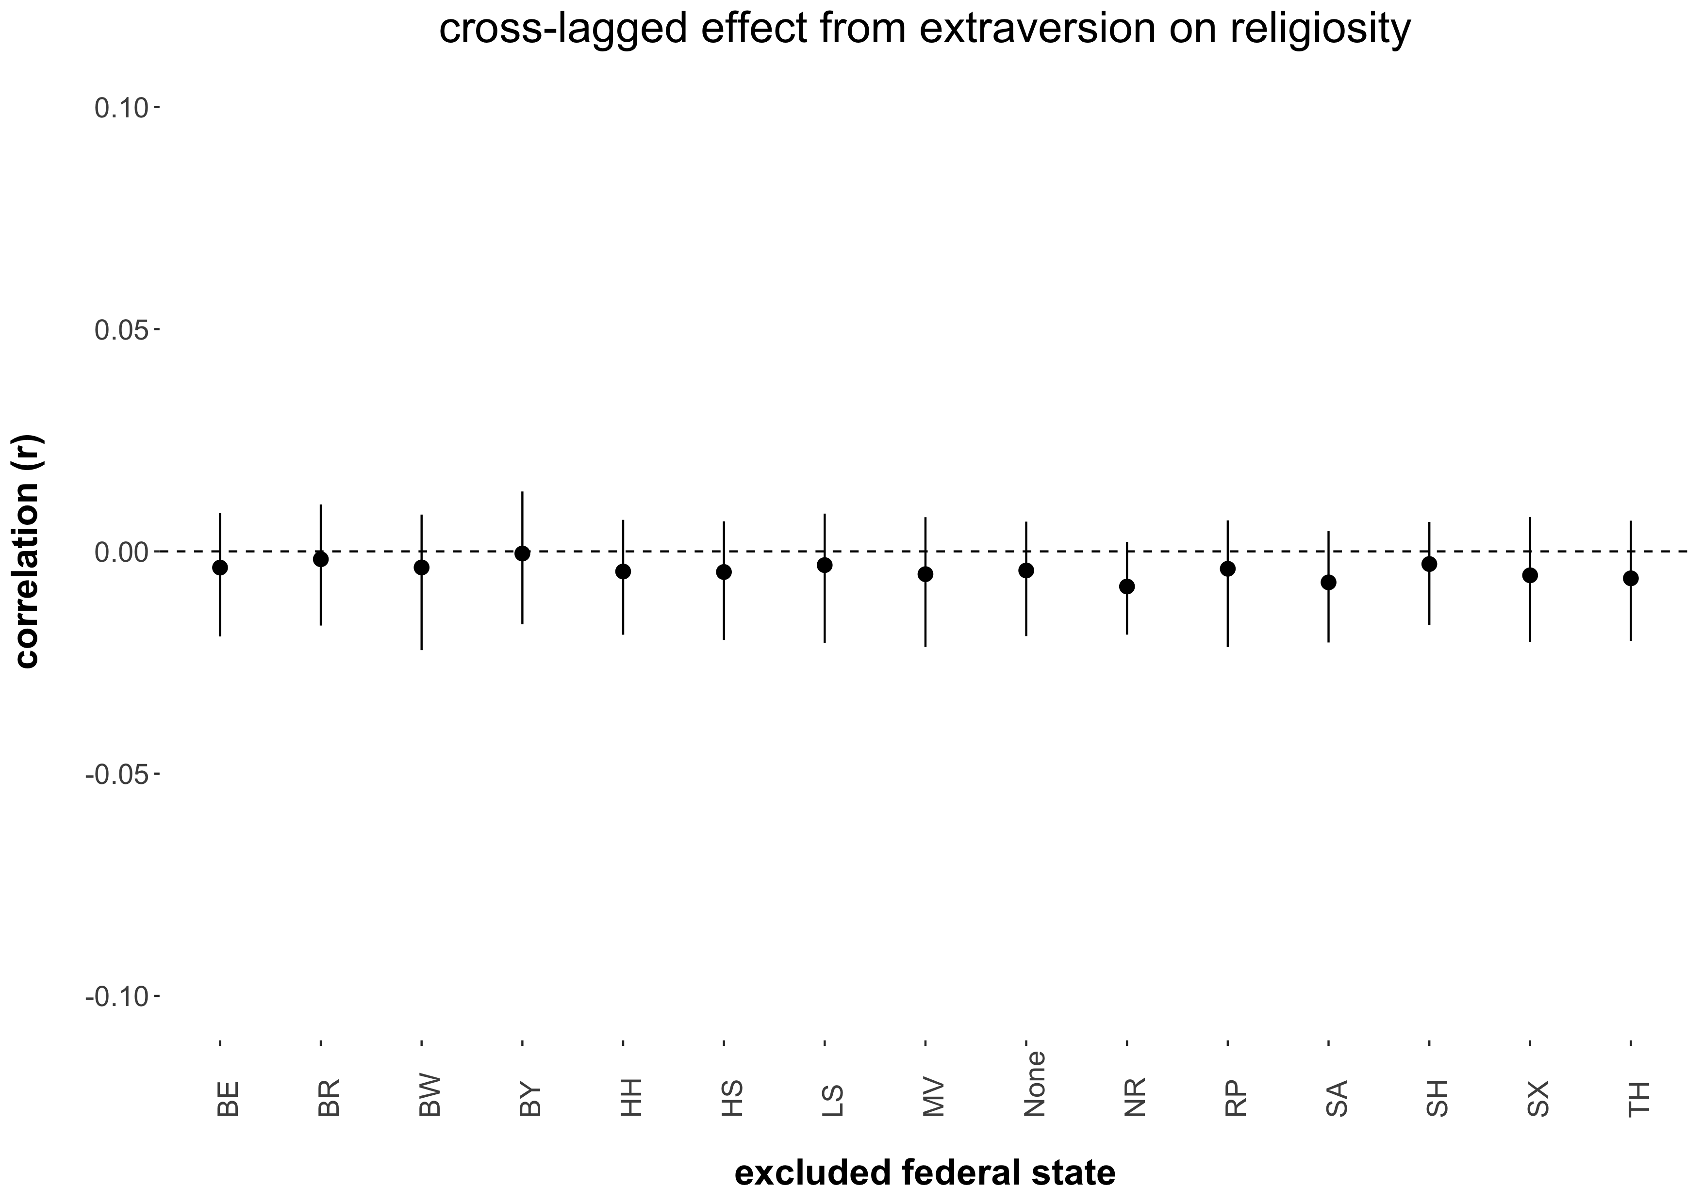

*Note.* The figure displays the point estimates and associated 95 percent confidence intervals (black vertical lines) of the cultural religiosity as moderator cross-lagged effect from extraversion on religiosity estimated when excluding a particular federal state from the meta-regression. MV = Mecklenburg-Vorpommern, SA = Saxony-Anhalt, BR = Brandenburg, SX = Saxony, BL = Berlin, TH = Thuringia, HH = Hamburg, SH = Schleswig-Holstein, LS = Lower-Saxony, HS = Hesse, NR = North Rhine – Westphalia, RP = Rhineland-Palatinate, BW = Baden-Württemberg, BA = Bavaria.

Figure S-2b.10

*Sensitivity Analysis for the Cultural Religiosity as Moderator Cross-Lagged Effect From Neuroticism on Religiosity*

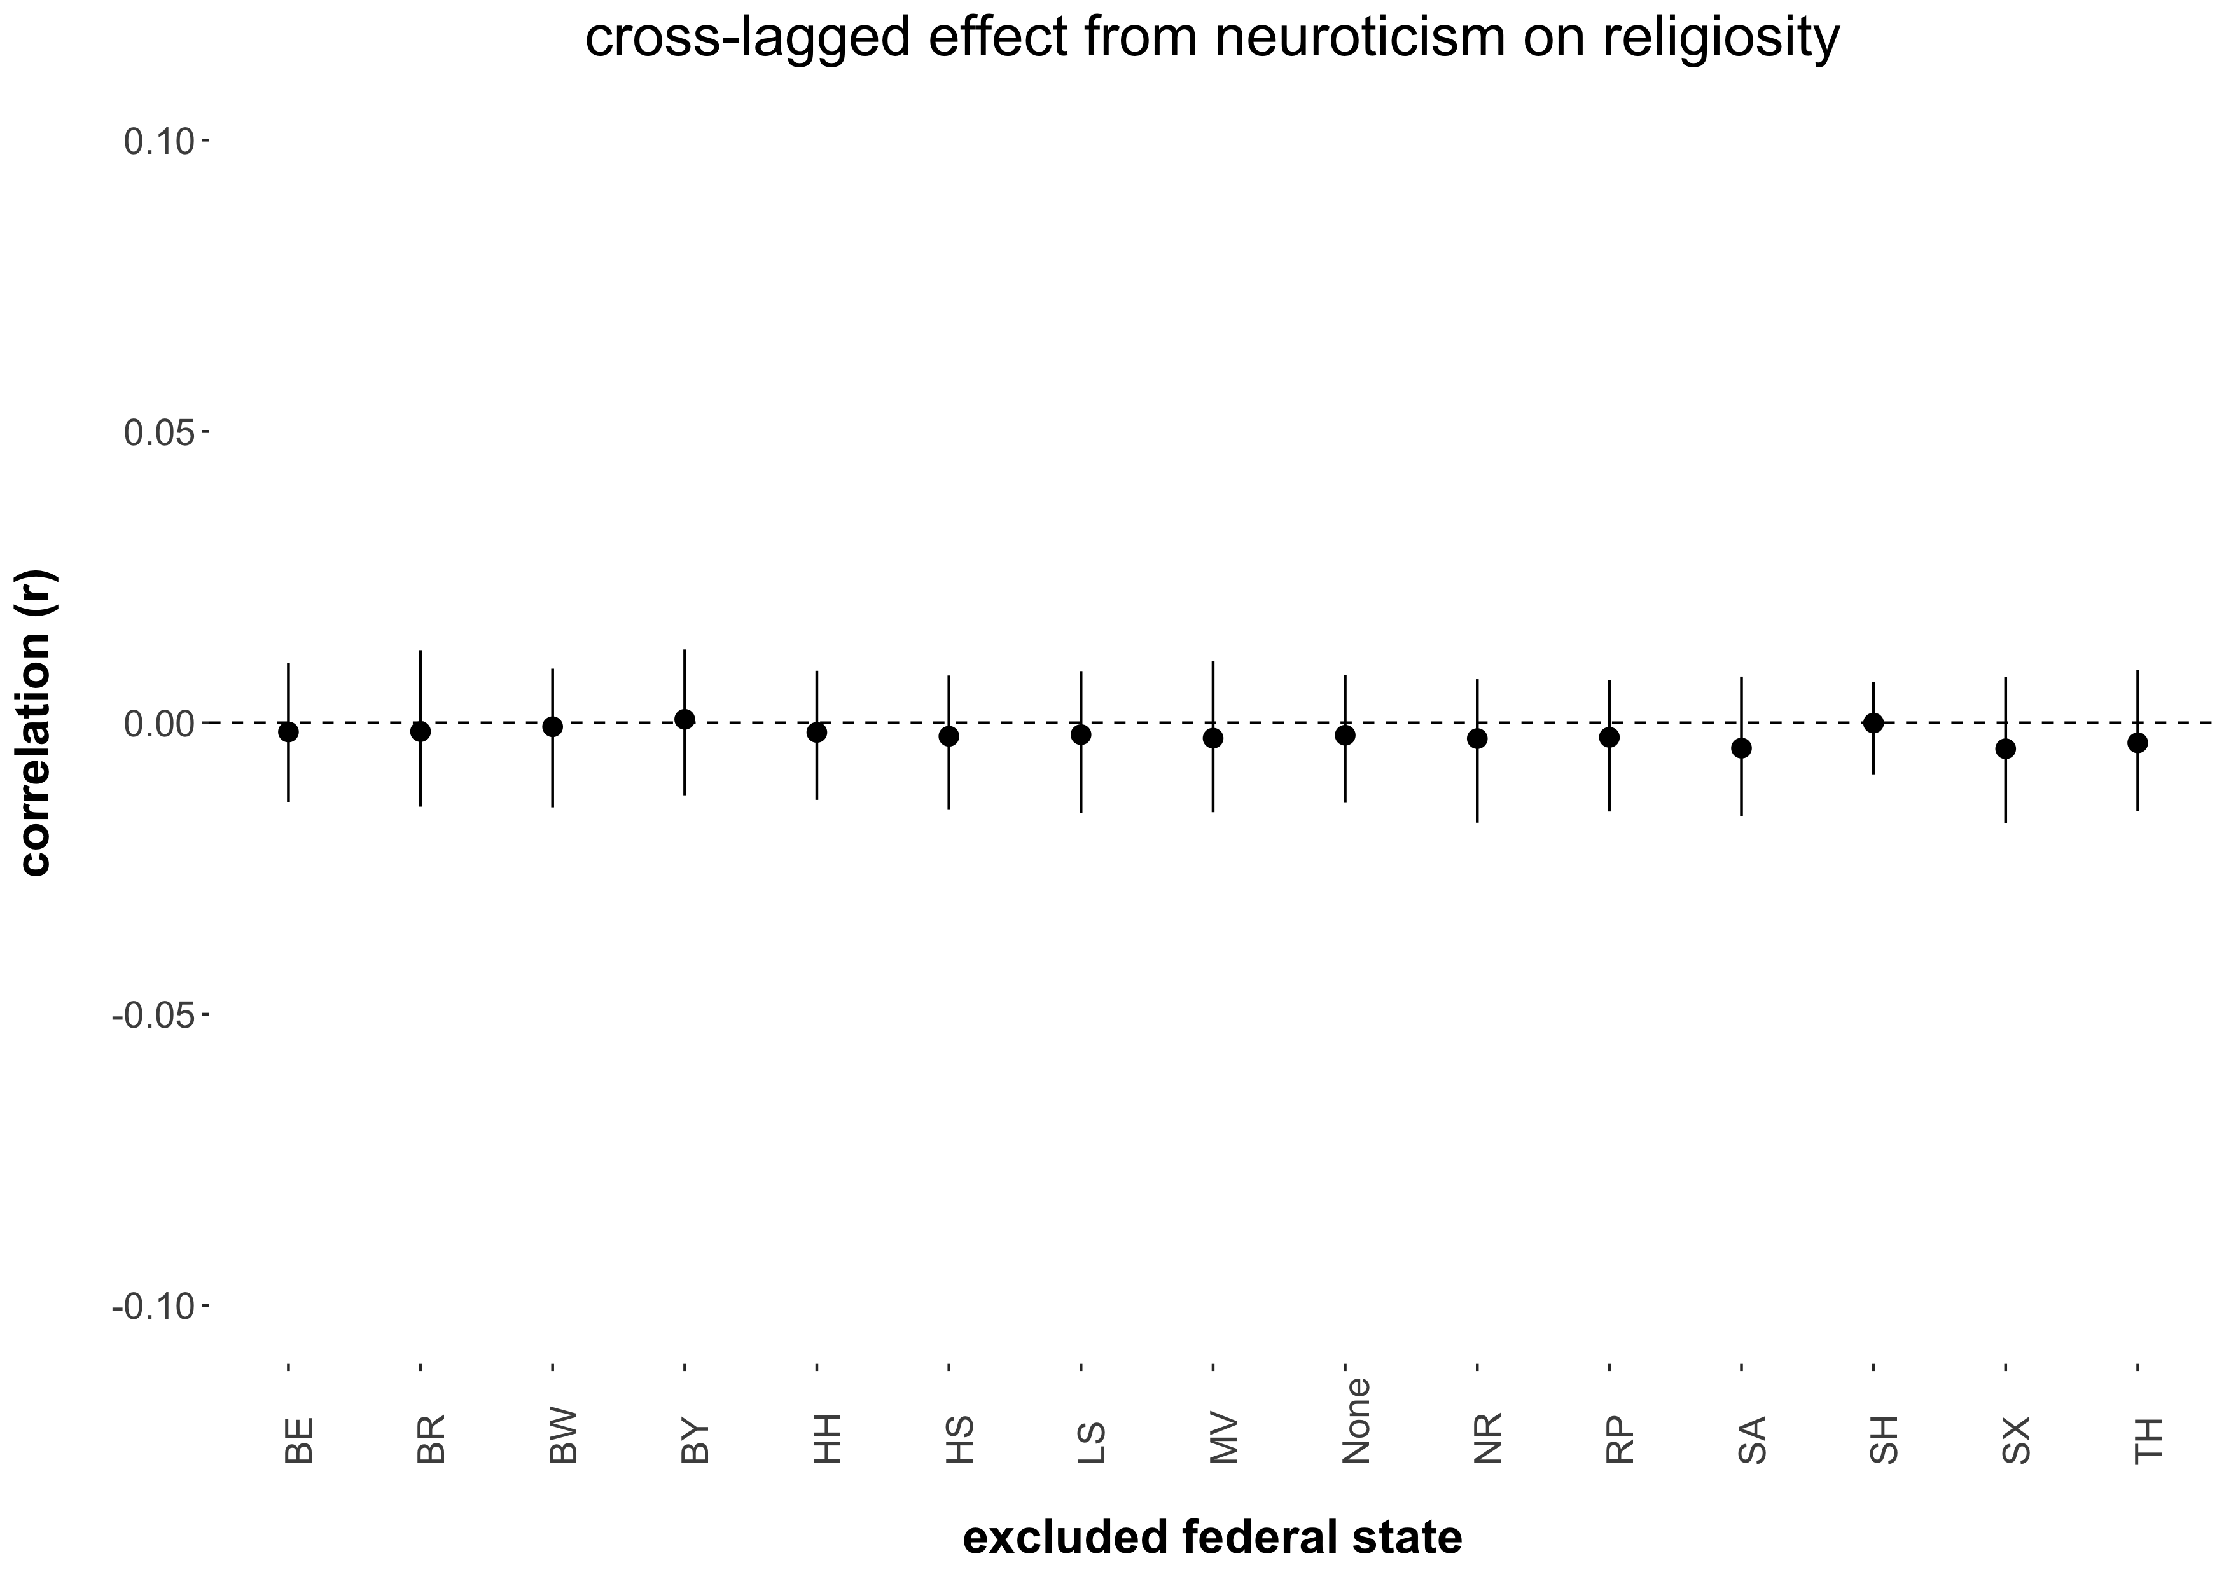

*Note.* The figure displays the point estimates and associated 95 percent confidence intervals (black vertical lines) of the cultural religiosity as moderator cross-lagged effect from neuroticism on religiosity estimated when excluding a particular federal state from the meta-regression. MV = Mecklenburg-Vorpommern, SA = Saxony-Anhalt, BR = Brandenburg, SX = Saxony, BL = Berlin, TH = Thuringia, HH = Hamburg, SH = Schleswig-Holstein, LS = Lower-Saxony, HS = Hesse, NR = North Rhine – Westphalia, RP = Rhineland-Palatinate, BW = Baden-Württemberg, BA = Bavaria.

**S-2c.** The following figures display the results from the sensitivity analysis of the stability effects (Table S-5a).

Figure S-2c.1

*Sensitivity Analysis of the Agreeableness Stability Effect*

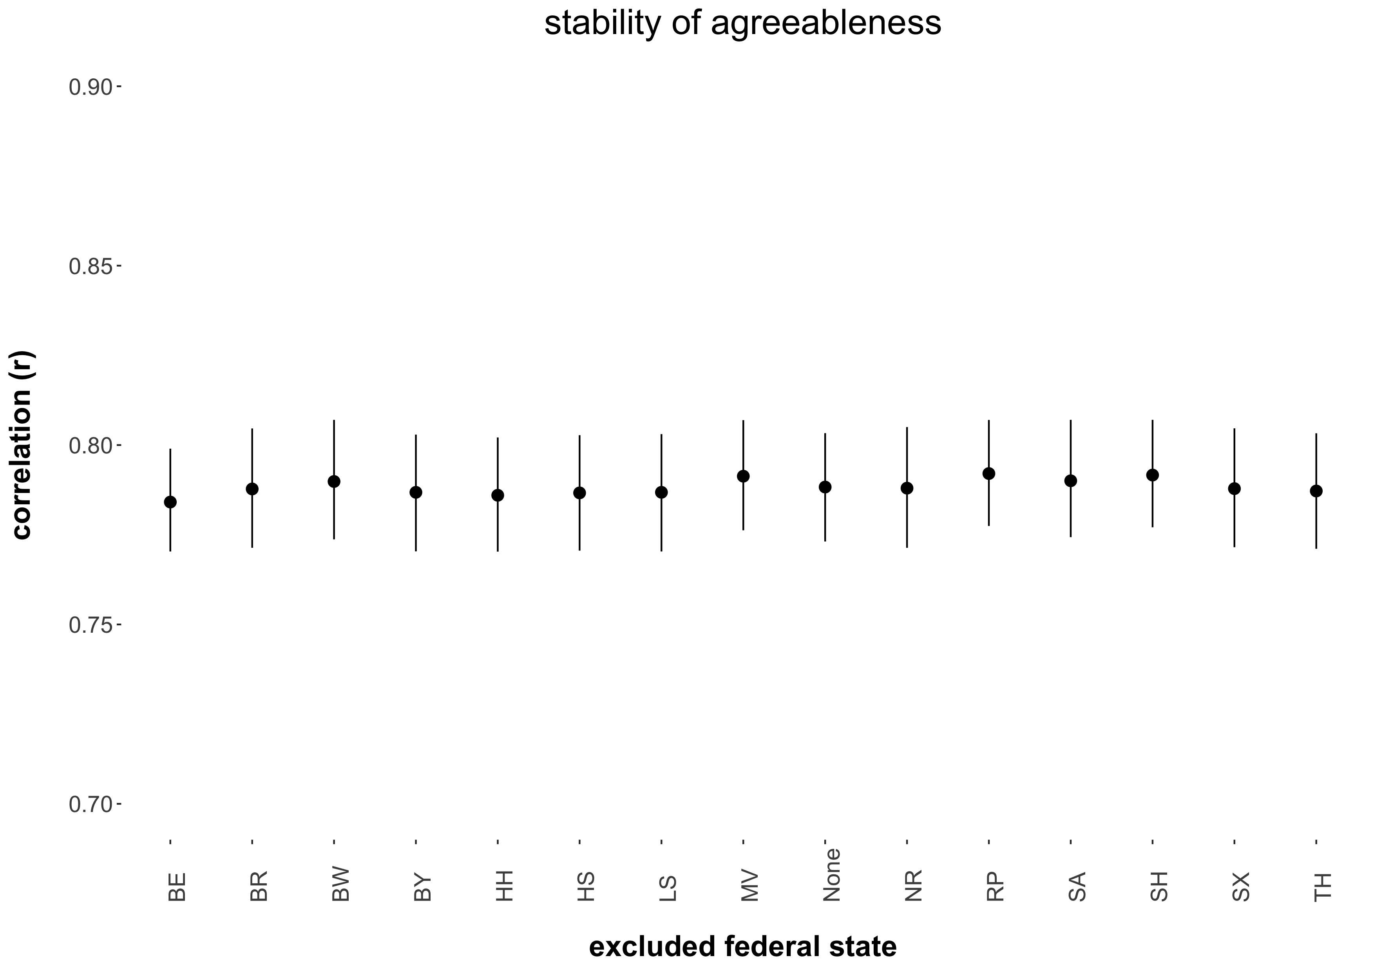

*Note.* The figure displays the point estimates and associated 95 percent confidence intervals (black vertical lines) of the agreeableness stability effect estimated when excluding a particular federal state from the meta-analysis. MV = Mecklenburg-Vorpommern, SA = Saxony-Anhalt, BR = Brandenburg, SX = Saxony, BL = Berlin, TH = Thuringia, HH = Hamburg, SH = Schleswig-Holstein, LS = Lower-Saxony, HS = Hesse, NR = North Rhine – Westphalia, RP = Rhineland-Palatinate, BW = Baden-Württemberg, BA = Bavaria.

Figure S-2c.2

*Sensitivity Analysis of the Openness Stability Effect*

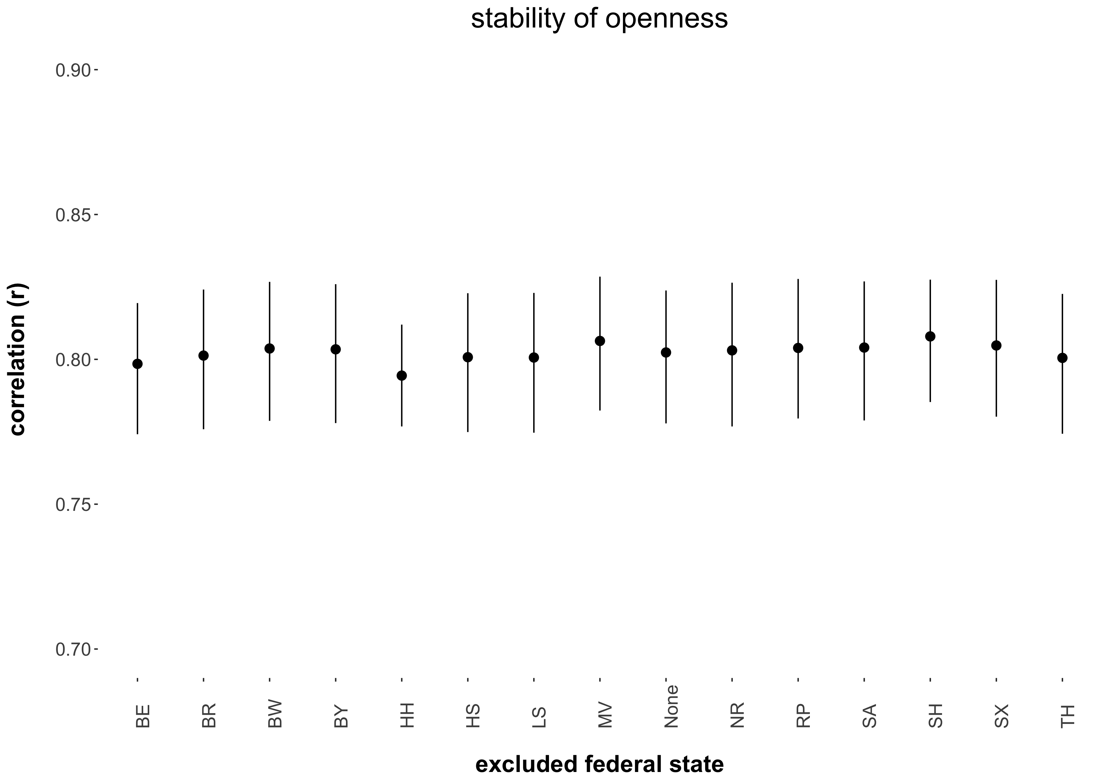

*Note.* The figure displays the point estimates and associated 95 percent confidence intervals (black vertical lines) of the openness stability effect estimated when excluding a particular federal state from the meta-analysis. MV = Mecklenburg-Vorpommern, SA = Saxony-Anhalt, BR = Brandenburg, SX = Saxony, BL = Berlin, TH = Thuringia, HH = Hamburg, SH = Schleswig-Holstein, LS = Lower-Saxony, HS = Hesse, NR = North Rhine – Westphalia, RP = Rhineland-Palatinate, BW = Baden-Württemberg, BA = Bavaria.

Figure S-2c.3

*Sensitivity Analysis of the Conscientiousness Stability Effect*

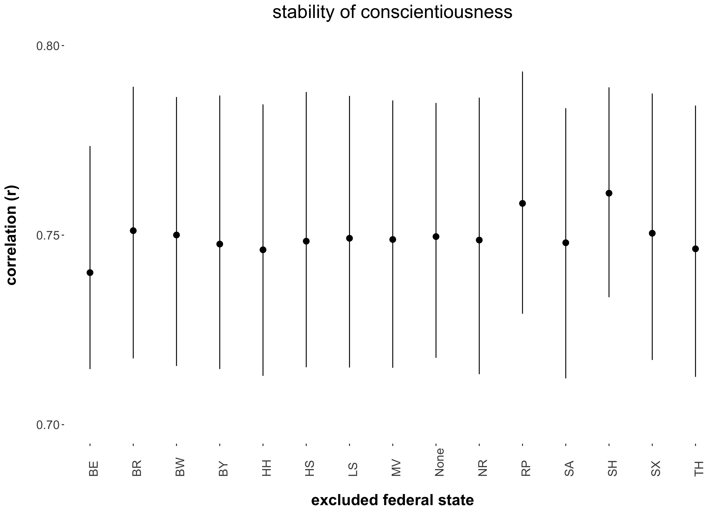

*Note.* The figure displays the point estimates and associated 95 percent confidence intervals (black vertical lines) of the conscientiousness stability effect estimated when excluding a particular federal state from the meta-analysis. MV = Mecklenburg-Vorpommern, SA = Saxony-Anhalt, BR = Brandenburg, SX = Saxony, BL = Berlin, TH = Thuringia, HH = Hamburg, SH = Schleswig-Holstein, LS = Lower-Saxony, HS = Hesse, NR = North Rhine – Westphalia, RP = Rhineland-Palatinate, BW = Baden-Württemberg, BA = Bavaria.

Figure S-2c.4

*Sensitivity Analysis of the Extraversion Stability Effect*

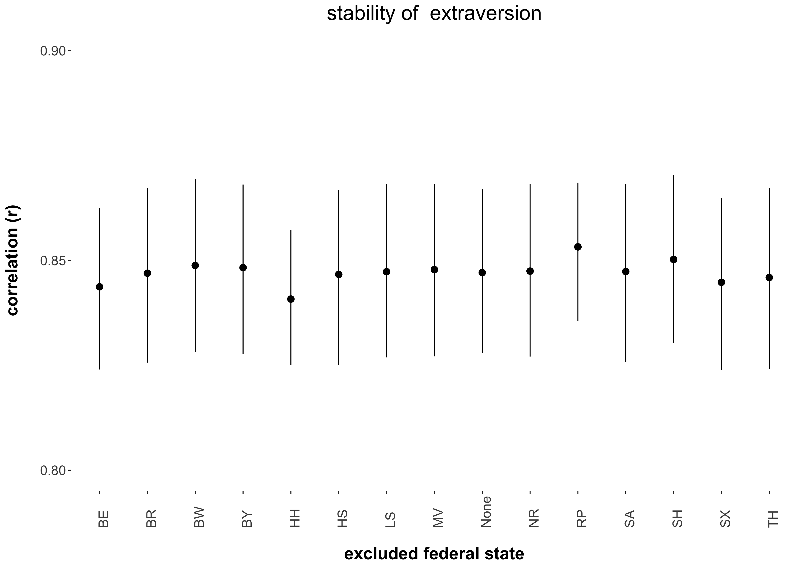

*Note.* The figure displays the point estimates and associated 95 percent confidence intervals (black vertical lines) of the extraversion stability effect estimated when excluding a particular federal state from the meta-analysis. MV = Mecklenburg-Vorpommern, SA = Saxony-Anhalt, BR = Brandenburg, SX = Saxony, BL = Berlin, TH = Thuringia, HH = Hamburg, SH = Schleswig-Holstein, LS = Lower-Saxony, HS = Hesse, NR = North Rhine – Westphalia, RP = Rhineland-Palatinate, BW = Baden-Württemberg, BA = Bavaria.

Figure S-2c.5

*Sensitivity Analysis of the Neuroticism Stability Effect*

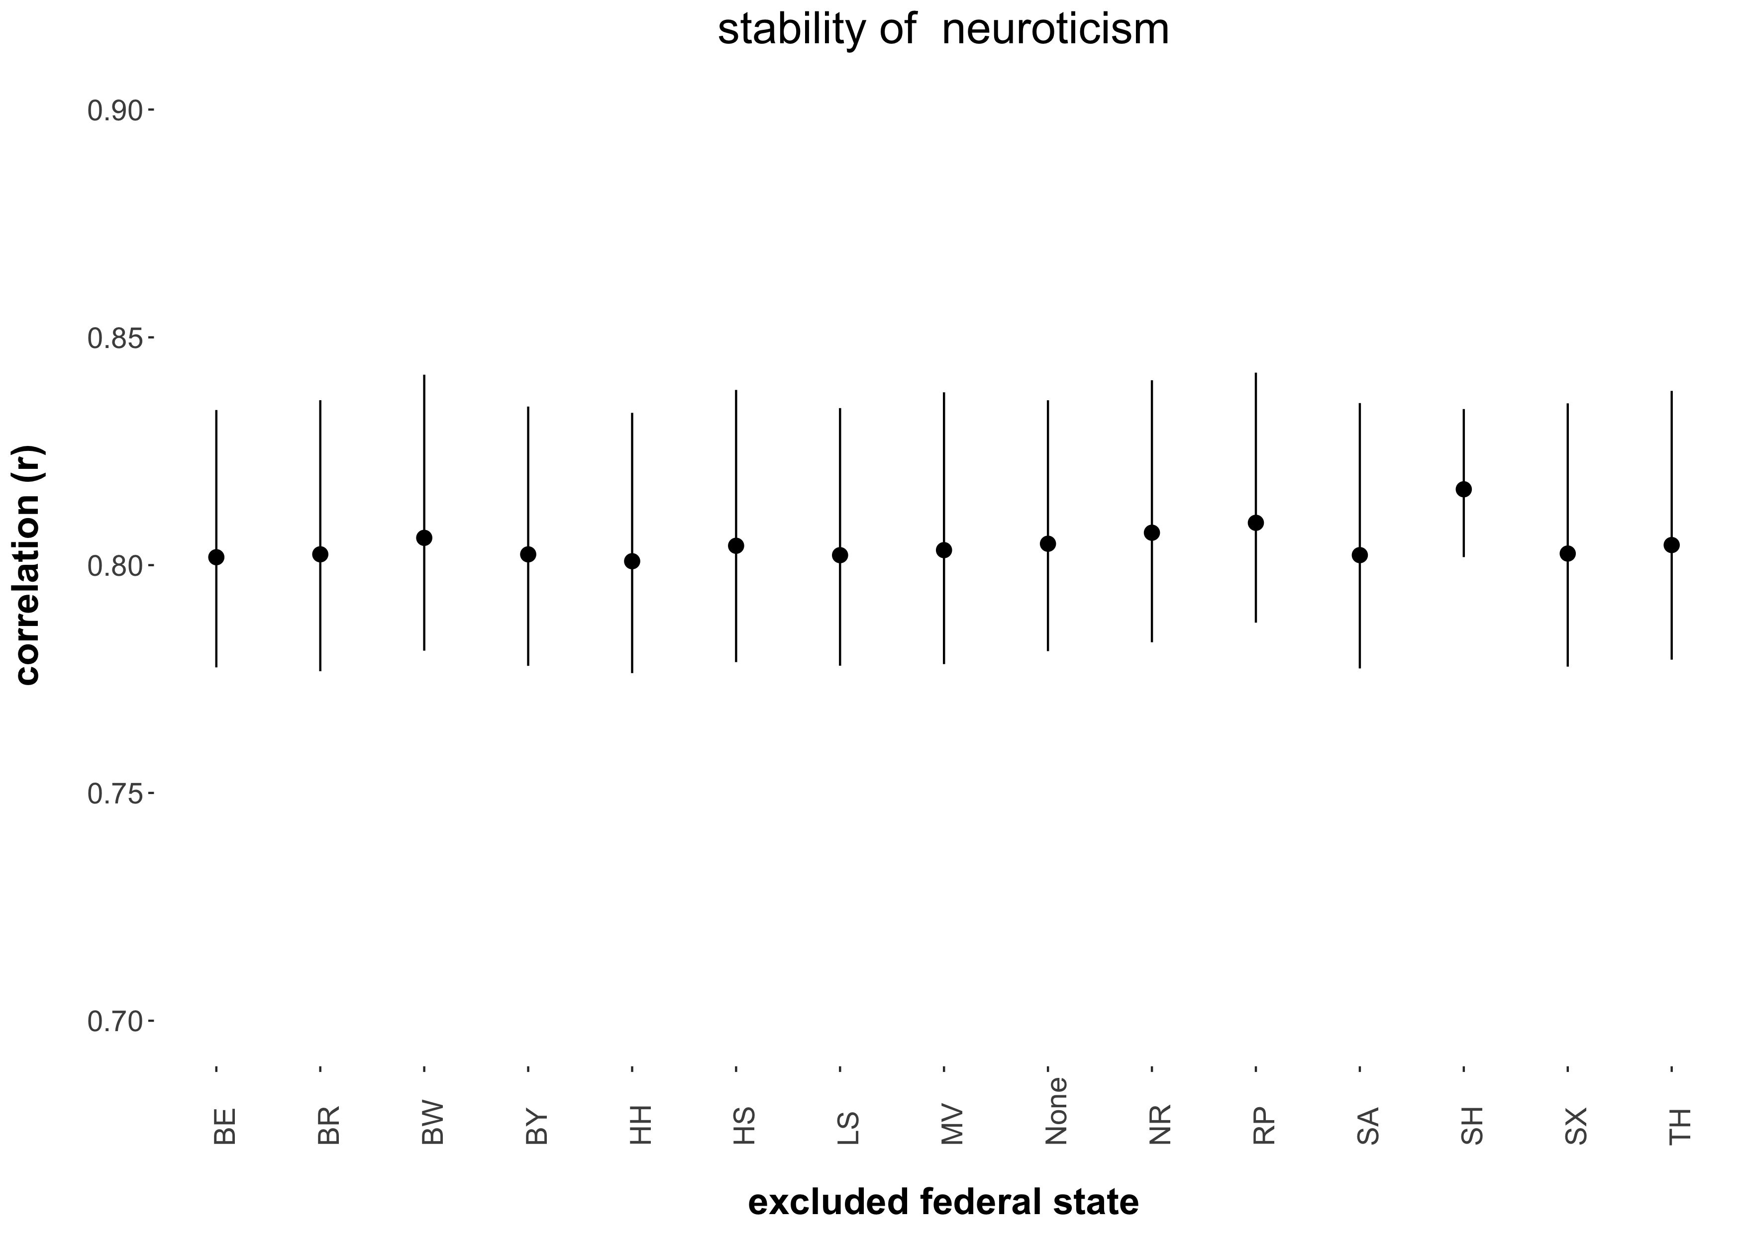

*Note.* The figure displays the point estimates and associated 95 percent confidence intervals (black vertical lines) of the neuroticism stability effect estimated when excluding a particular federal state from the meta-analysis. MV = Mecklenburg-Vorpommern, SA = Saxony-Anhalt, BR = Brandenburg, SX = Saxony, BL = Berlin, TH = Thuringia, HH = Hamburg, SH = Schleswig-Holstein, LS = Lower-Saxony, HS = Hesse, NR = North Rhine – Westphalia, RP = Rhineland-Palatinate, BW = Baden-Württemberg, BA = Bavaria.

Figure S-2c.6

*Sensitivity Analysis of the Religiosity Stability Effect*

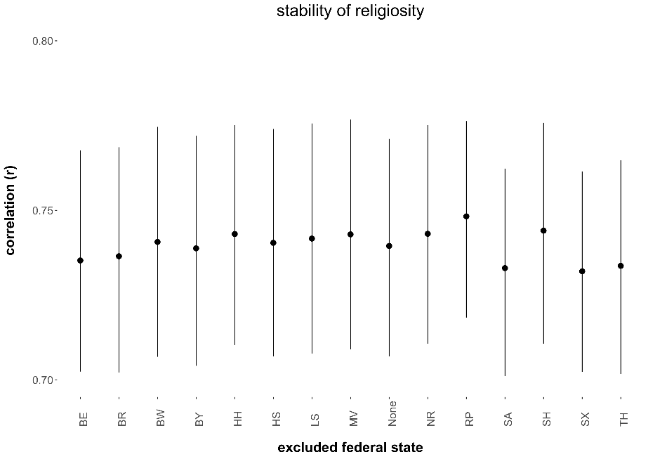

*Note.* The figure displays the point estimates and associated 95 percent confidence intervals (black vertical lines) of the religiosity stability effect estimated when excluding a particular federal state from the meta-analysis. MV = Mecklenburg-Vorpommern, SA = Saxony-Anhalt, BR = Brandenburg, SX = Saxony, BL = Berlin, TH = Thuringia, HH = Hamburg, SH = Schleswig-Holstein, LS = Lower-Saxony, HS = Hesse, NR = North Rhine – Westphalia, RP = Rhineland-Palatinate, BW = Baden-Württemberg, BA = Bavaria.

**S-2d.** The following figures display the results from the sensitivity analyses of the correlated change effects between religiosity and the Big Five personality traits (Table S-5b).

**Omnibus effects**

Figure S-2d.1

*Sensitivity Analysis of the Omnibus Correlated Change Effect Between Religiosity and Agreeableness*

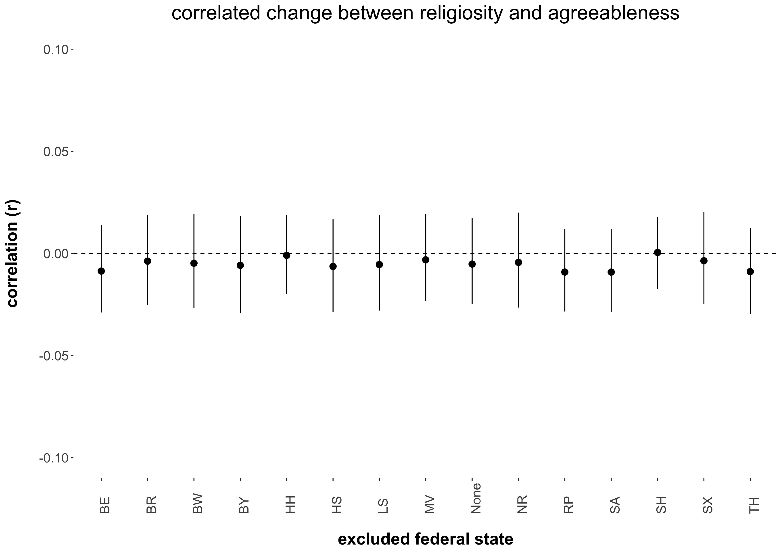

*Note.* The figure displays the point estimates and associated 95 percent confidence intervals (black vertical lines) of the omnibus correlated change effect between religiosity and agreeableness estimated when excluding a particular federal state from the meta-analysis. MV = Mecklenburg-Vorpommern, SA = Saxony-Anhalt, BR = Brandenburg, SX = Saxony, BL = Berlin, TH = Thuringia, HH = Hamburg, SH = Schleswig-Holstein, LS = Lower-Saxony, HS = Hesse, NR = North Rhine – Westphalia, RP = Rhineland-Palatinate, BW = Baden-Württemberg, BA = Bavaria.

Figure S-2d.2

*Sensitivity Analysis of the Omnibus Correlated Change Effect Between Religiosity and Openness*

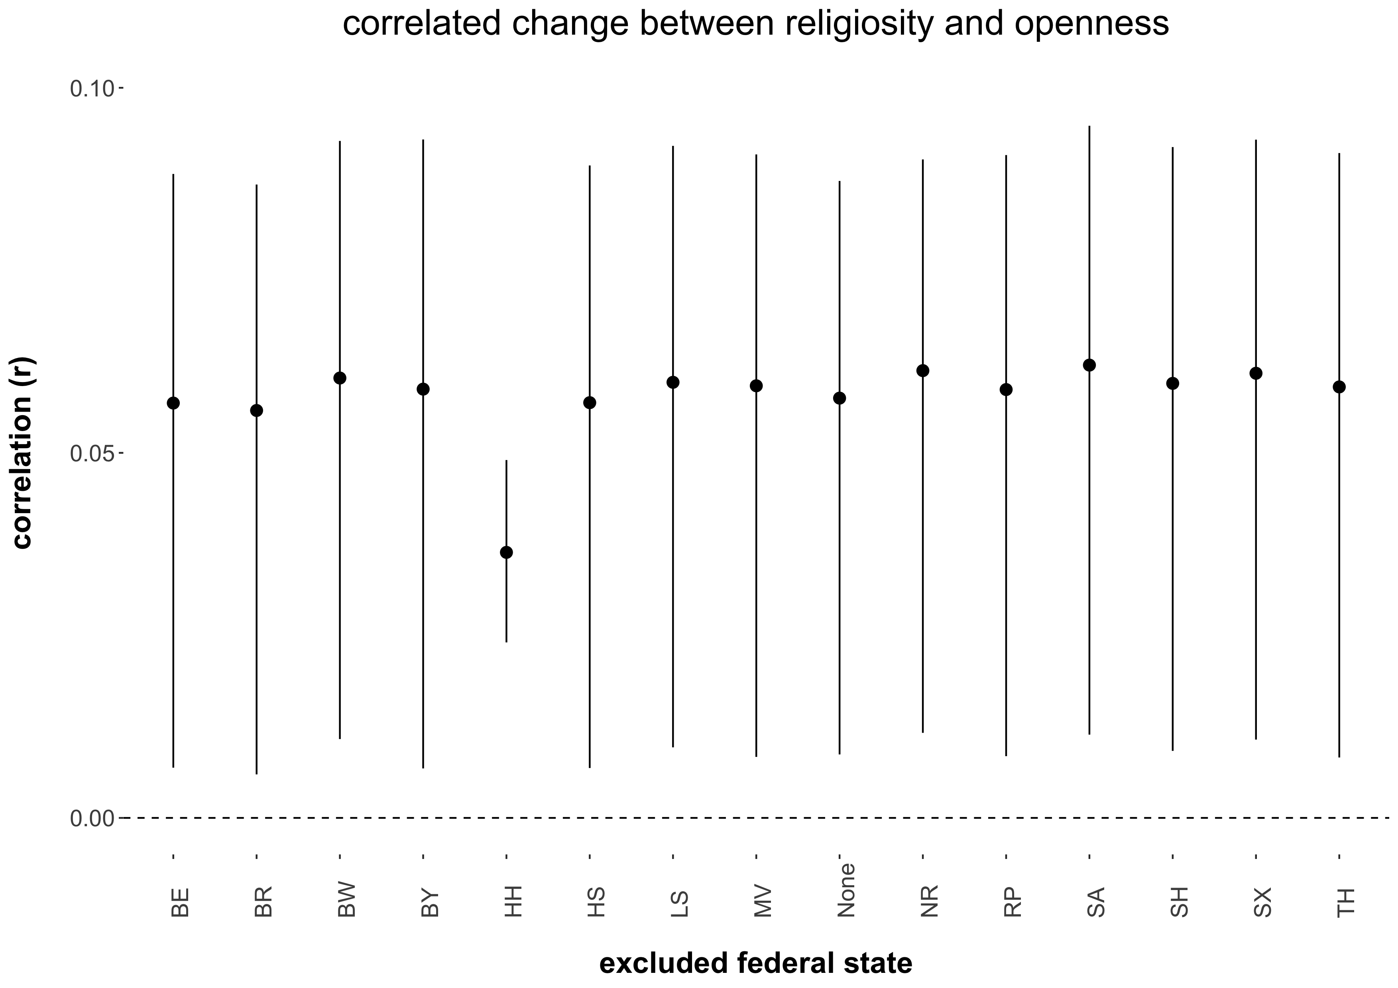

*Note.* The figure displays the point estimates and associated 95 percent confidence intervals (black vertical lines) of the omnibus correlated change effect between religiosity and openness estimated when excluding a particular federal state from the meta-analysis. MV = Mecklenburg-Vorpommern, SA = Saxony-Anhalt, BR = Brandenburg, SX = Saxony, BL = Berlin, TH = Thuringia, HH = Hamburg, SH = Schleswig-Holstein, LS = Lower-Saxony, HS = Hesse, NR = North Rhine – Westphalia, RP = Rhineland-Palatinate, BW = Baden-Württemberg, BA = Bavaria.

Figure S-2d.3

*Sensitivity Analysis of the Omnibus Correlated Change Effect Between Religiosity and Conscientiousness*

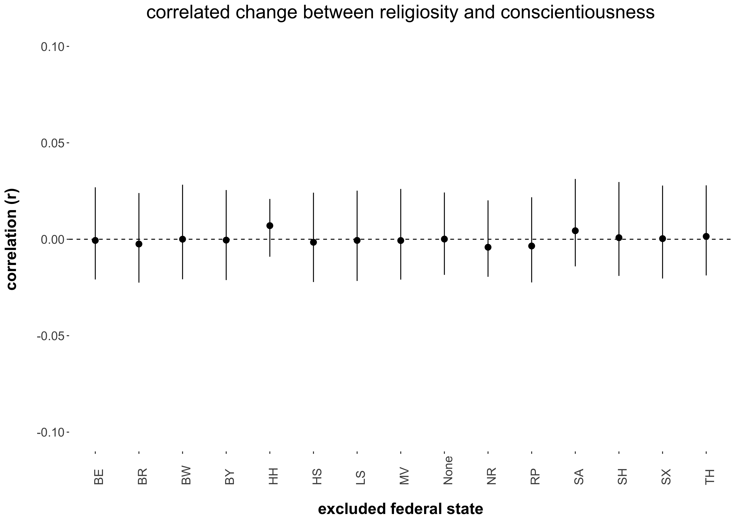

*Note.* The figure displays the point estimates and associated 95 percent confidence intervals (black vertical lines) of the omnibus correlated change effect between religiosity and conscientiousness estimated when excluding a particular federal state from the meta-analysis. MV = Mecklenburg-Vorpommern, SA = Saxony-Anhalt, BR = Brandenburg, SX = Saxony, BL = Berlin, TH = Thuringia, HH = Hamburg, SH = Schleswig-Holstein, LS = Lower-Saxony, HS = Hesse, NR = North Rhine – Westphalia, RP = Rhineland-Palatinate, BW = Baden-Württemberg, BA = Bavaria.

Figure S-2d.4

*Sensitivity Analysis of the Omnibus Correlated Change Effect Between Religiosity and Extraversion*

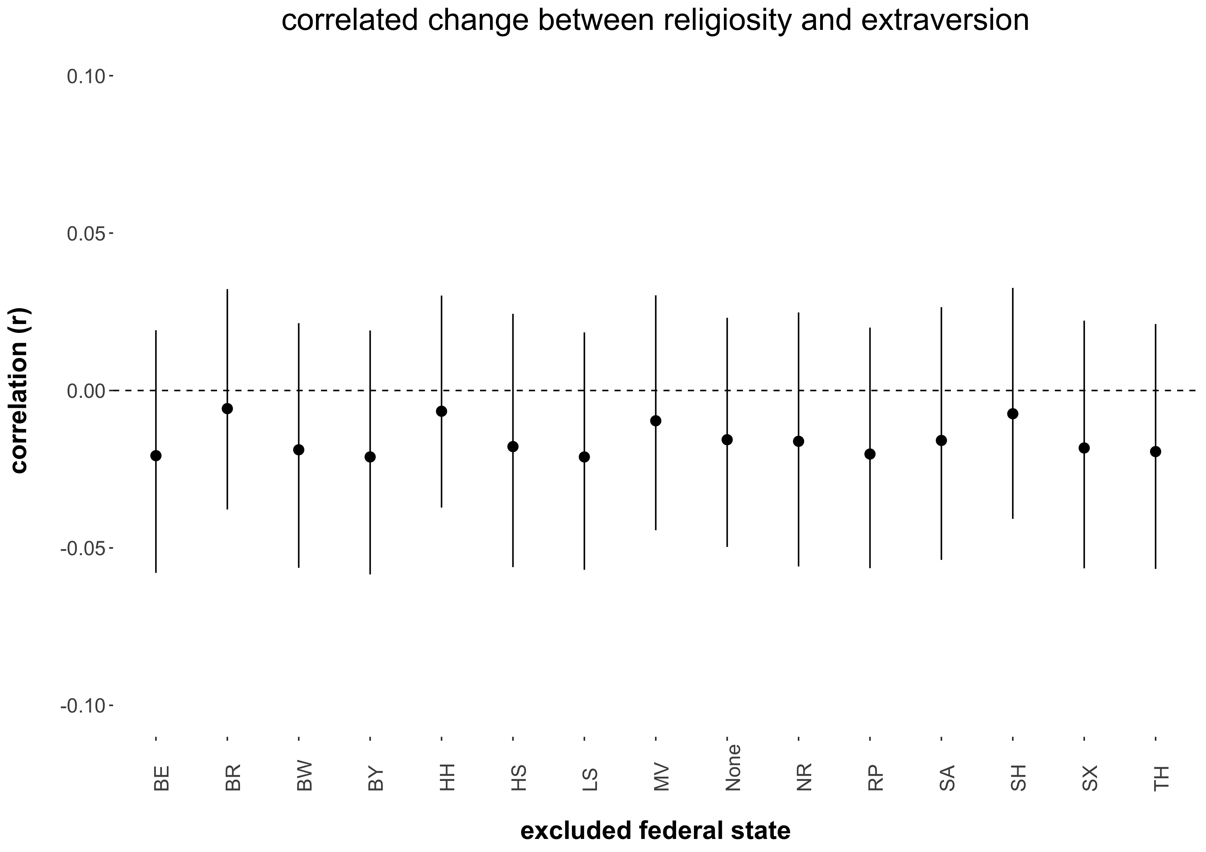

*Note.* The figure displays the point estimates and associated 95 percent confidence intervals (black vertical lines) of the omnibus correlated change effect between religiosity and extraversion estimated when excluding a particular federal state from the meta-analysis. MV = Mecklenburg-Vorpommern, SA = Saxony-Anhalt, BR = Brandenburg, SX = Saxony, BL = Berlin, TH = Thuringia, HH = Hamburg, SH = Schleswig-Holstein, LS = Lower-Saxony, HS = Hesse, NR = North Rhine – Westphalia, RP = Rhineland-Palatinate, BW = Baden-Württemberg, BA = Bavaria.

Figure S-2d.5

*Sensitivity Analysis of the Omnibus Correlated Change Effect Between Religiosity and Neuroticism*

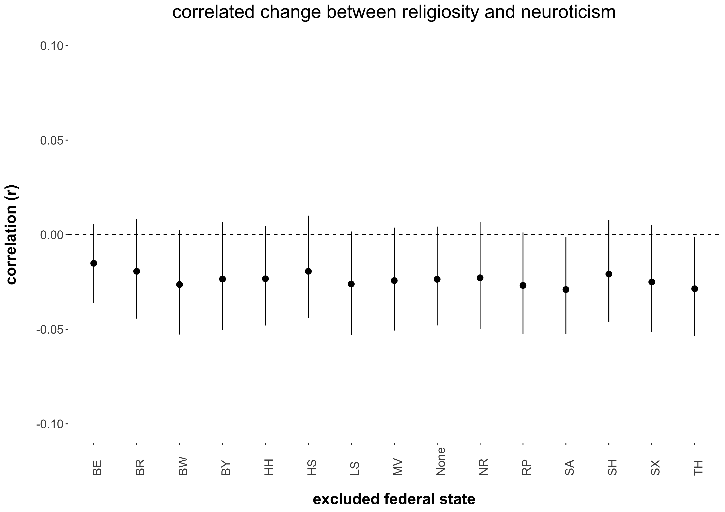

*Note.* The figure displays the point estimates and associated 95 percent confidence intervals (black vertical lines) of the omnibus correlated change effect between religiosity and neuroticism estimated when excluding a particular federal state from the meta-analysis. MV = Mecklenburg-Vorpommern, SA = Saxony-Anhalt, BR = Brandenburg, SX = Saxony, BL = Berlin, TH = Thuringia, HH = Hamburg, SH = Schleswig-Holstein, LS = Lower-Saxony, HS = Hesse, NR = North Rhine – Westphalia, RP = Rhineland-Palatinate, BW = Baden-Württemberg, BA = Bavaria.

**Cultural Religiosity as Moderator Effects**

Figure S-2d.6

*Sensitivity Analysis of the Cultural Religiosity as Moderator Correlated Change Effect Between Religiosity and Agreeableness*

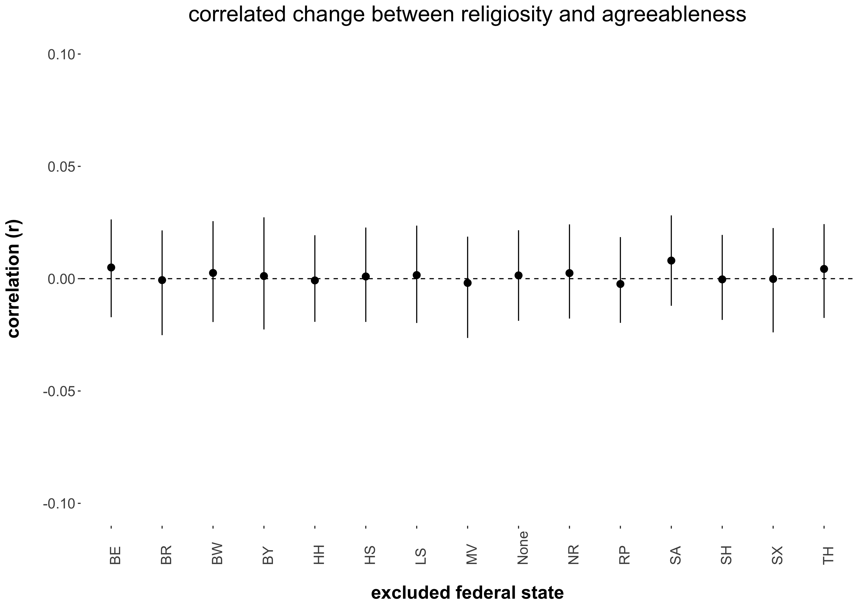

*Note.* The figure displays the point estimates and associated 95 percent confidence intervals (black vertical lines) of the cultural religiosity as moderator correlated change effect between religiosity and agreeableness estimated when excluding a particular federal state from the meta-regression. MV = Mecklenburg-Vorpommern, SA = Saxony-Anhalt, BR = Brandenburg, SX = Saxony, BL = Berlin, TH = Thuringia, HH = Hamburg, SH = Schleswig-Holstein, LS = Lower-Saxony, HS = Hesse, NR = North Rhine – Westphalia, RP = Rhineland-Palatinate, BW = Baden-Württemberg, BA = Bavaria.

Figure S-2d.7

*Sensitivity Analysis of the Cultural Religiosity as Moderator Correlated Change Effect Between Religiosity and Openness*

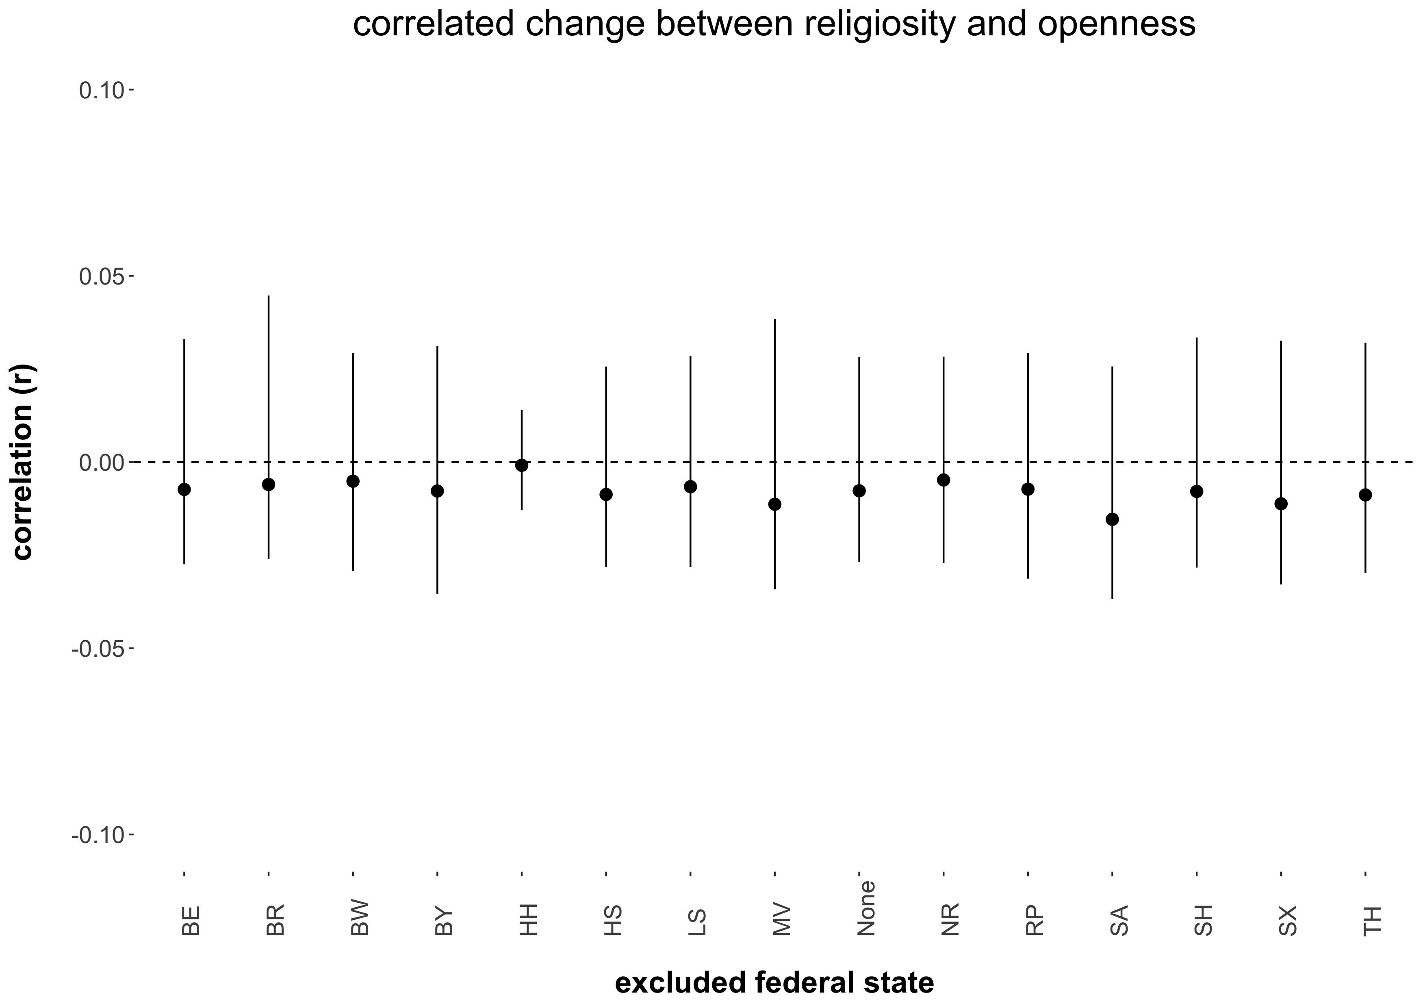

*Note.* The figure displays the point estimates and associated 95 percent confidence intervals (black vertical lines) of the cultural religiosity as moderator correlated change effect between religiosity and openness estimated when excluding a particular federal state from the meta-regression. MV = Mecklenburg-Vorpommern, SA = Saxony-Anhalt, BR = Brandenburg, SX = Saxony, BL = Berlin, TH = Thuringia, HH = Hamburg, SH = Schleswig-Holstein, LS = Lower-Saxony, HS = Hesse, NR = North Rhine – Westphalia, RP = Rhineland-Palatinate, BW = Baden-Württemberg, BA = Bavaria.

Figure S-2d.8

*Sensitivity Analysis of the Cultural Religiosity as Moderator Correlated Change Effect Between Religiosity and Conscientiousness*

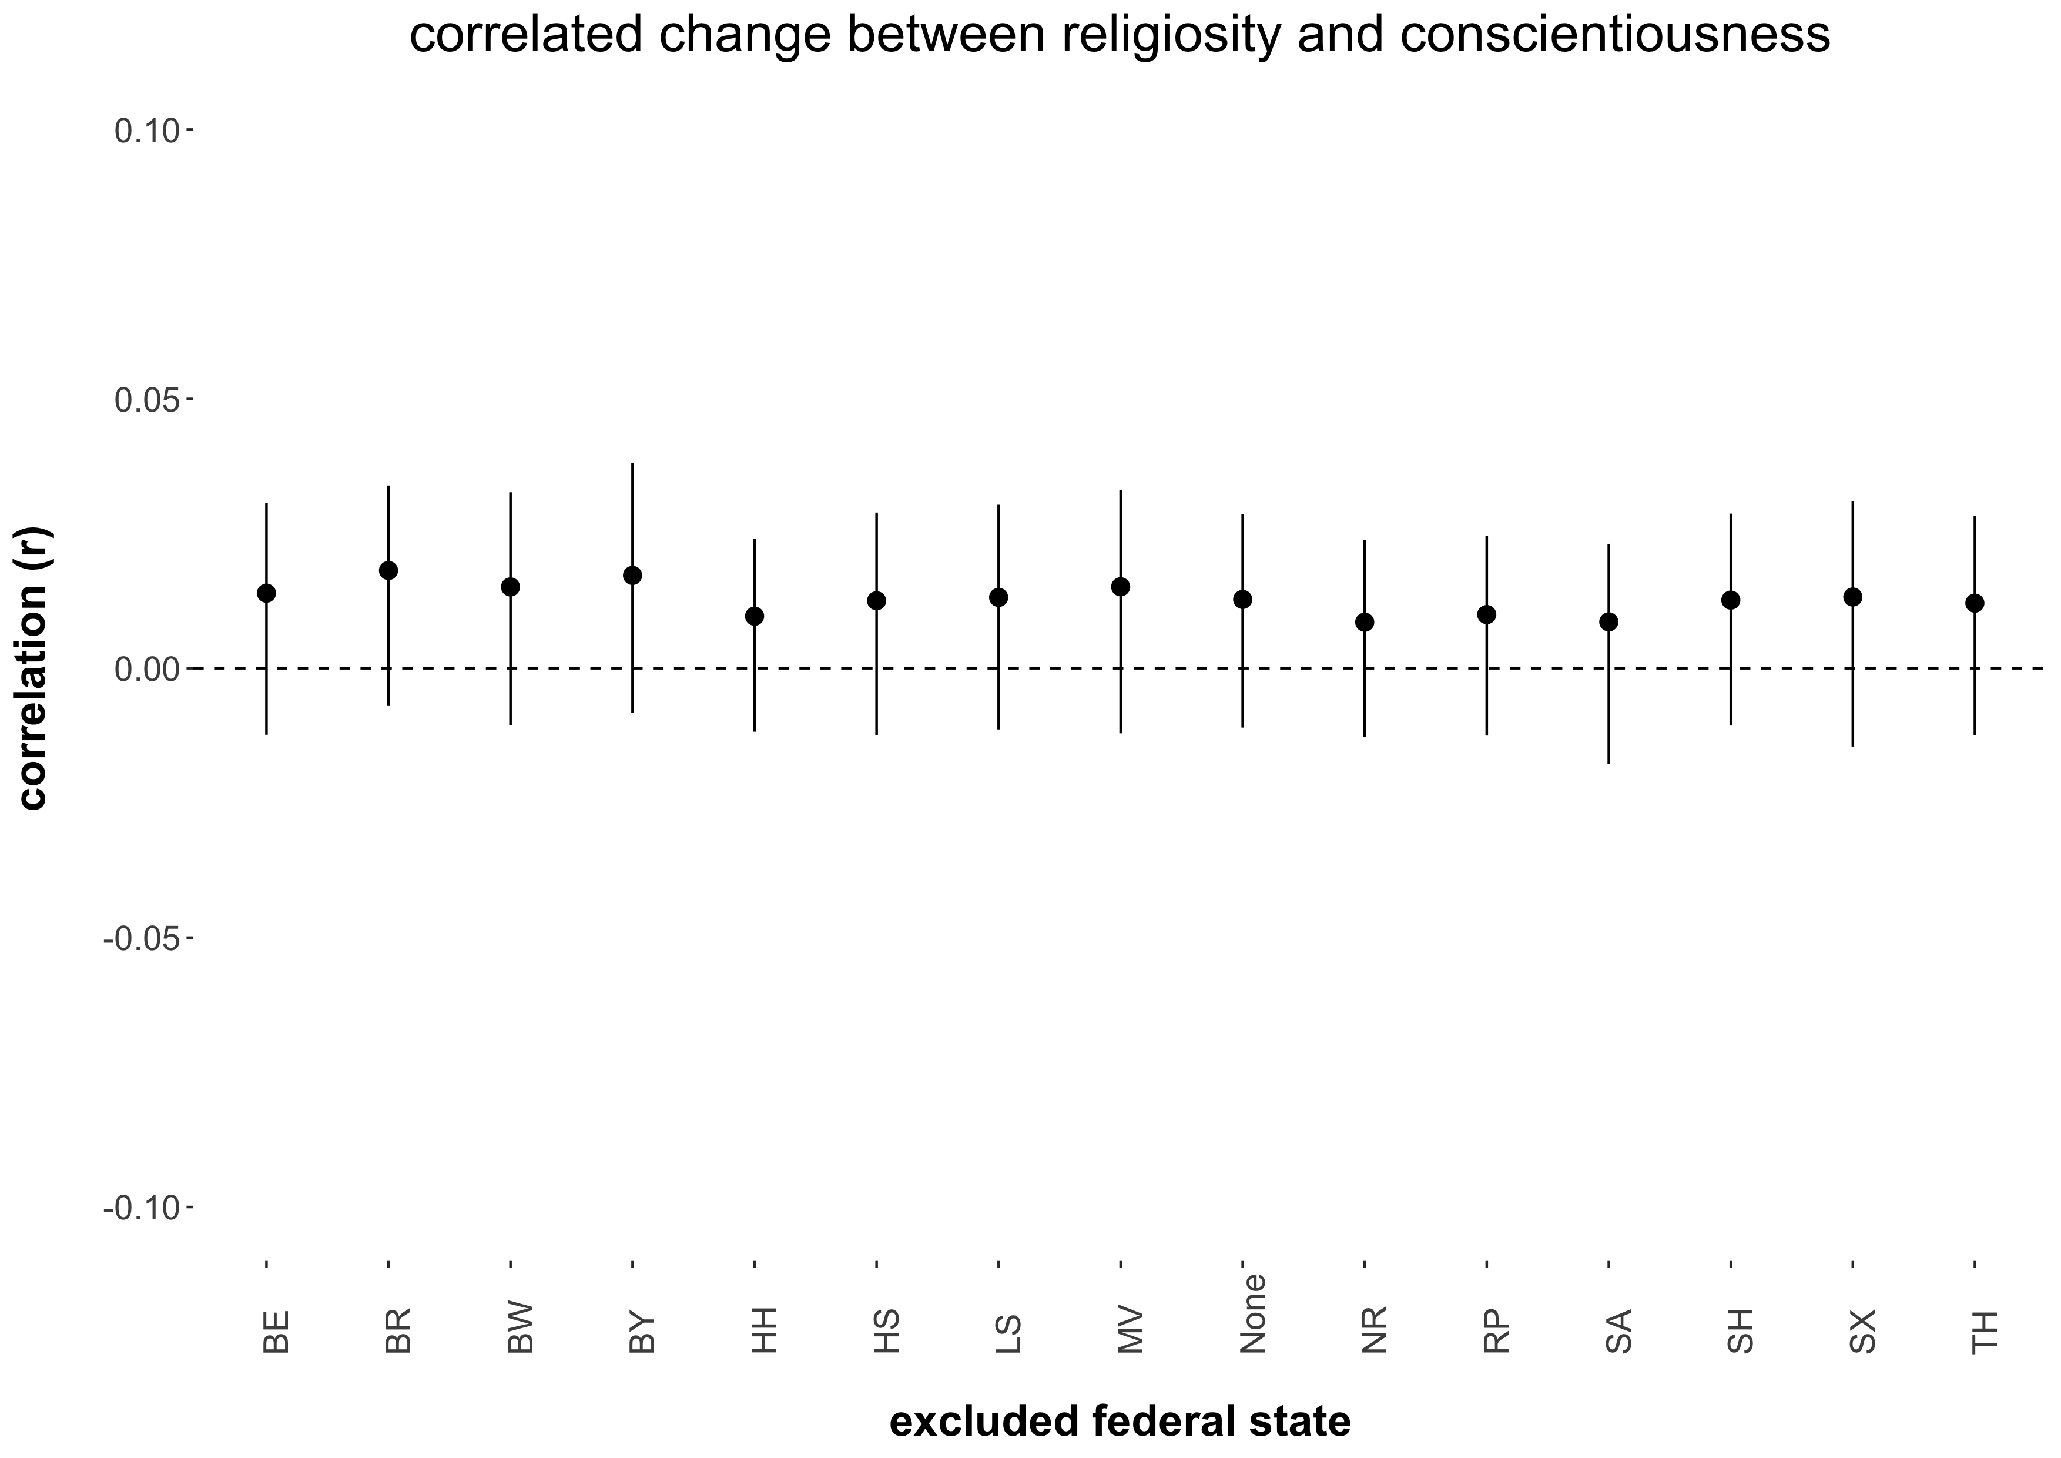

*Note.* The figure displays the point estimates and associated 95 percent confidence intervals (black vertical lines) of the cultural religiosity as moderator correlated change effect between religiosity and conscientiousness estimated when excluding a particular federal state from the meta-regression. MV = Mecklenburg-Vorpommern, SA = Saxony-Anhalt, BR = Brandenburg, SX = Saxony, BL = Berlin, TH = Thuringia, HH = Hamburg, SH = Schleswig-Holstein, LS = Lower-Saxony, HS = Hesse, NR = North Rhine – Westphalia, RP = Rhineland-Palatinate, BW = Baden-Württemberg, BA = Bavaria.

Figure S-2d.9

*Sensitivity Analysis of the Cultural Religiosity as Moderator Correlated Change Effect Between Religiosity and Extraversion*

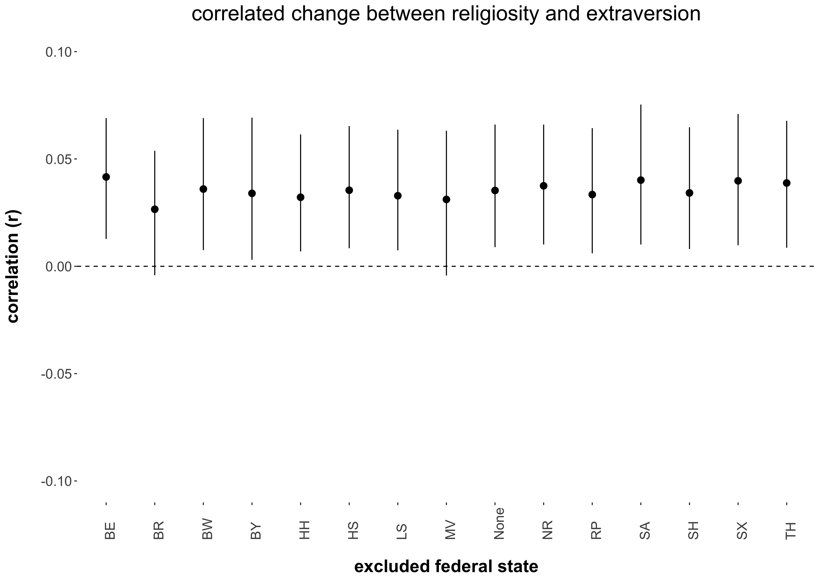

*Note.* The figure displays the point estimates and associated 95 percent confidence intervals (black vertical lines) of the cultural religiosity as moderator correlated change effect between religiosity and extraversion estimated when excluding a particular federal state from the meta-regression. MV = Mecklenburg-Vorpommern, SA = Saxony-Anhalt, BR = Brandenburg, SX = Saxony, BL = Berlin, TH = Thuringia, HH = Hamburg, SH = Schleswig-Holstein, LS = Lower-Saxony, HS = Hesse, NR = North Rhine – Westphalia, RP = Rhineland-Palatinate, BW = Baden-Württemberg, BA = Bavaria.

Figure S-2d.10

*Sensitivity Analysis of the Cultural Religiosity as Moderator Correlated Change Effect Between Religiosity and Neuroticism*

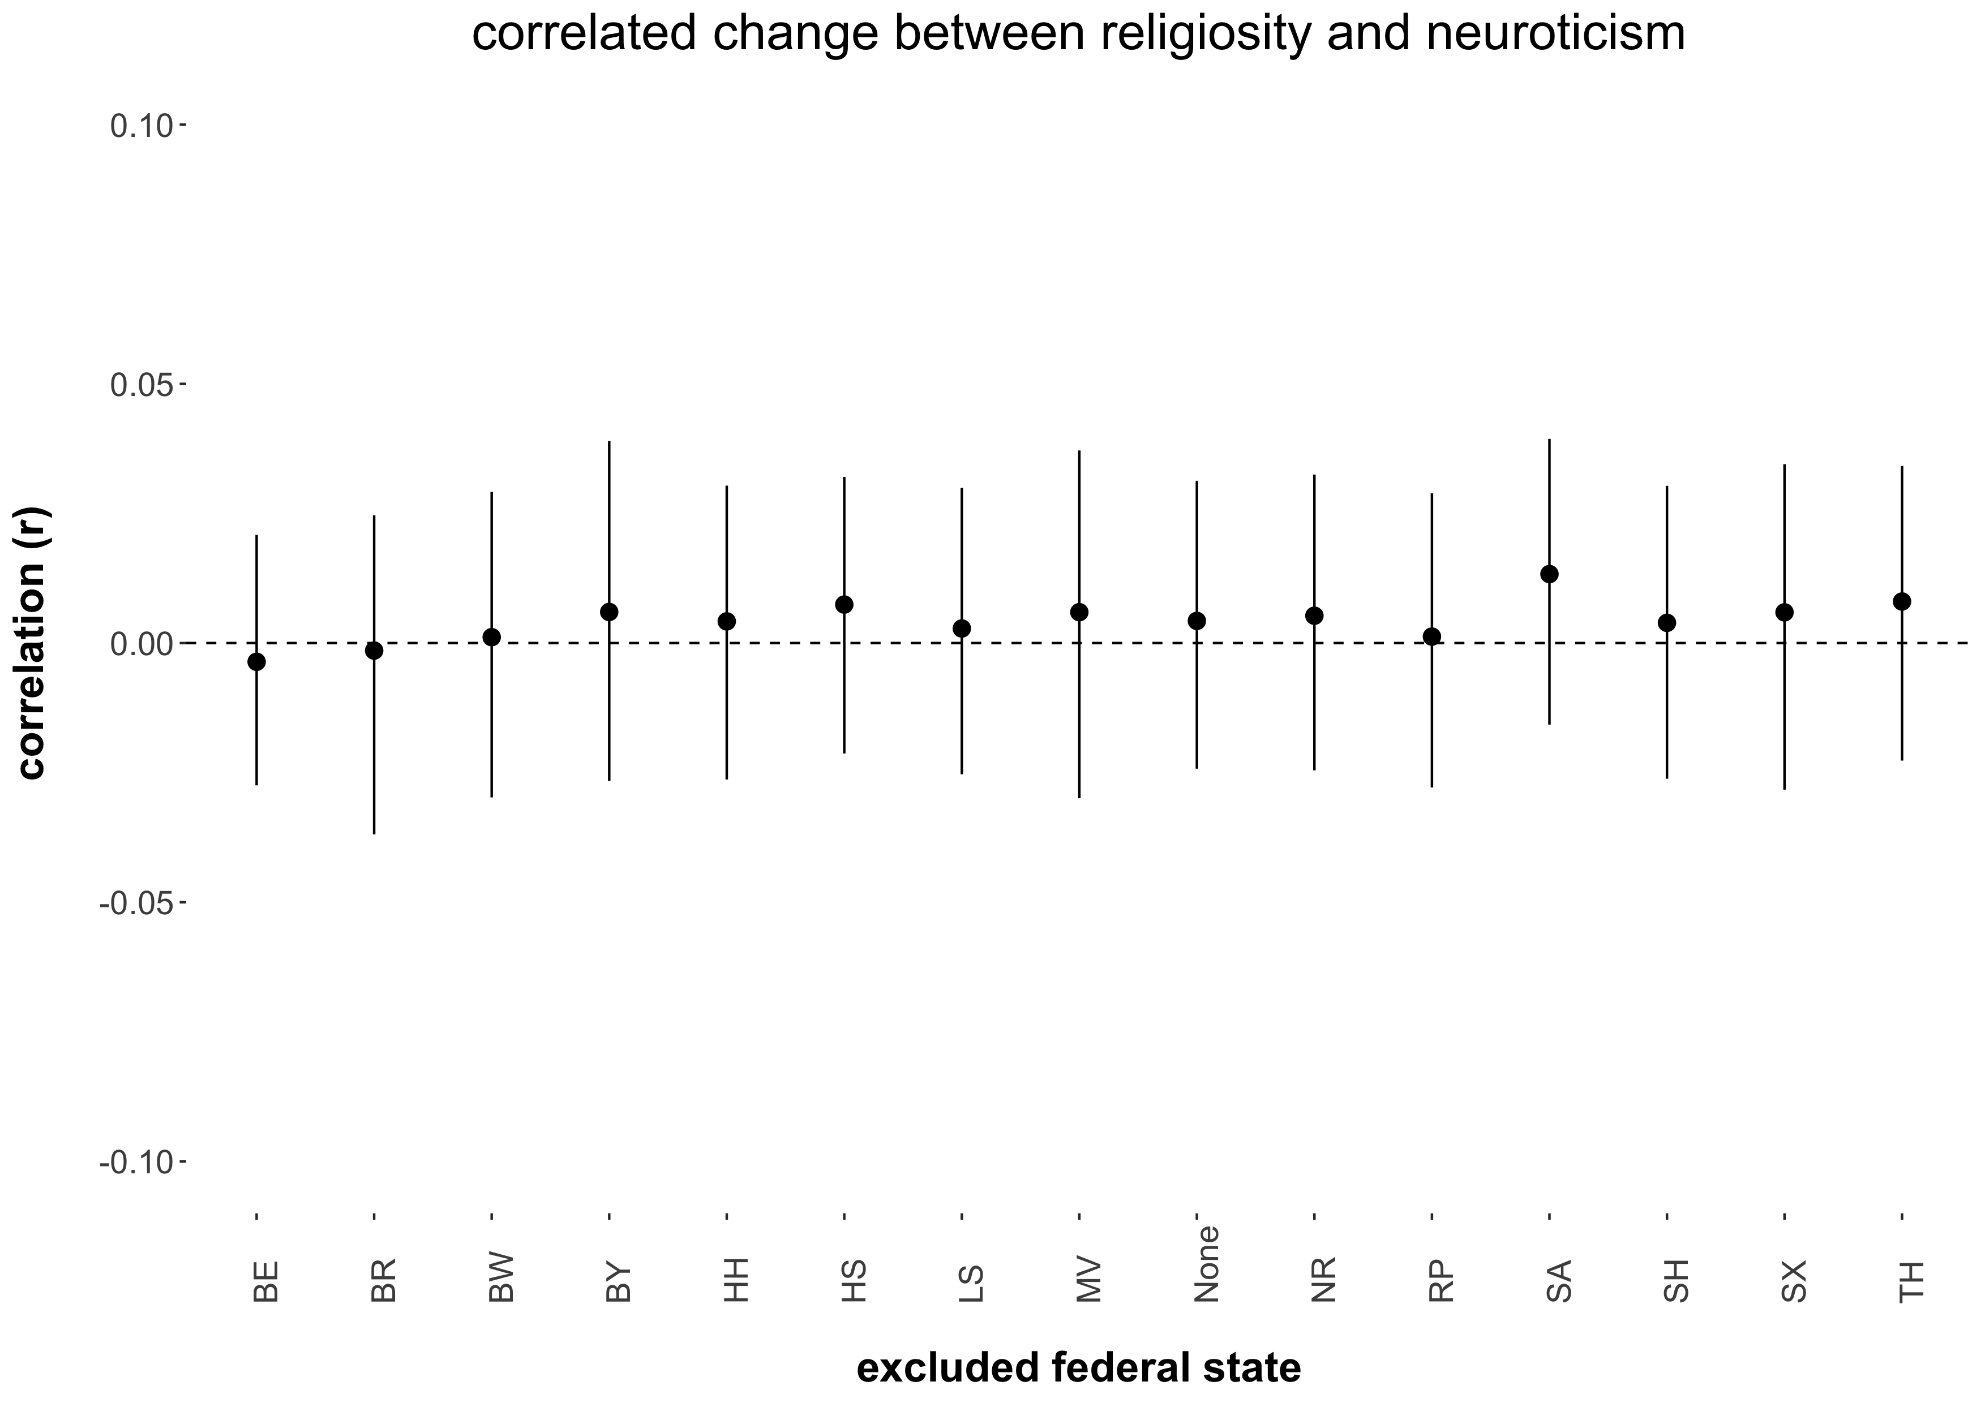

*Note.* The figure displays the point estimates and associated 95 percent confidence intervals (black vertical lines) of the cultural religiosity as moderator correlated change effect between religiosity and neuroticism estimated when excluding a particular federal state from the meta-regression. MV = Mecklenburg-Vorpommern, SA = Saxony-Anhalt, BR = Brandenburg, SX = Saxony, BL = Berlin, TH = Thuringia, HH = Hamburg, SH = Schleswig-Holstein, LS = Lower-Saxony, HS = Hesse, NR = North Rhine – Westphalia, RP = Rhineland-Palatinate, BW = Baden-Württemberg, BA = Bavaria.

**S-3.** The main-text analyses excluded data from the two smallest German federal states, because their sample sizes were too small for our statistical models to converge. Table S-3a (cross-lagged effects from religiosity on the Big Five traits) and S-3b (cross-lagged effects from the Big Five traits on religiosity) each report two sets of supplementary analyses, which include the data from Bremen and from the Saarland. In set 1, the data from Bremen was included into the sample from Lower-Saxony (a federal state that surrounds the city state of Bremen) and the data from the Saarland was included into the sample from Rhineland-Palatinate (the Saarland’s closest neighboring state). In set 2, we computed a single model on the basis of all data from all 16 federal states of Germany. As is almost all SOEP research, this set-2 model is inattentive to the state level (here: state-level differences in religiosity). Yet, the cross-lagged effects of that model are probably more telling than the omnibus cross-lagged effects from set 1. Overall, the two sets of supplementary analyses buttressed our main-text results. There were only two minor differences. The first minor difference was that the cross-lagged effect from religiosity on later changes in agreeableness was significant at a *95%-level* in the main-text analyses, *β* = .011, 95% CI [.0004, .022], and at a *90%-level* in set 1 of the supplementary analyses, *β* = .009, 90% CI [.0002, .019]. Importantly, though, in set 2 of the supplementary analyses the cross-lagged effect from religiosity on later changes in agreeableness was significant at the 95%-level, *β* = .011, 95% CI [.002, .019].

The second minor difference was that the cross-lagged effect from openness on later changes in religiosity was significant at the *95%-level* in set 2 of the supplementary analyses, *β* = -.014, 95% CI [-.025, -.003]. In the main text analyses, however, it was only significant at the *90%-level*, *β* = -.013, 90% CI [-.025, -.00009] and in set 1 of the supplementary analyses it was not significant at all, *β* = -.012, 90% CI [-.025, .002].

Table S-3a

*Cross-lagged Effects from Religiosity on the Big Five Traits Estimated Within Each Federal State and the Associated Meta-Analytical Results Using the Combined Sample*

|  |  |  |  |  |  |  |  |  |  |
| --- | --- | --- | --- | --- | --- | --- | --- | --- | --- |
| state |  |  | state-level religiosity |  | cross-lagged effects (*β*) of religiosity on changes in the Big Five | | | | |
|  |
| *N* |  |  | religiosity 🡪  ∆agreeableness | religiosity 🡪  ∆openness | religiosity 🡪  ∆conscientiousness | religiosity 🡪  ∆extraversion | religiosity 🡪  ∆neuroticism |
| Bavaria | 7,085 |  | 1.95 |  | -.004 [-.026, .018] | -.020 [-.041, .001] | -.013 [-.033, .008] | -.002 [-.020, .017] | .004 [-.015, .024] |
| Baden-Wuerttemberg | 5,423 |  | 1.85 |  | .017 [-.008, .042] | -.026 [-.050, -.002] | -.026 [-.051, -.001] | -.004 [-.025, .018] | -1E-04 [-.023, .023] |
| Rhineland-Palatinate + Saarland | 2,564 |  | 1.80 |  | -.034 [-.074, .006] | -.046 [-.082, -.010] | -.022 [-.061, .018] | .005 [-.026, .037] | .006 [-.030, .042] |
| North Rhine-Westphalia | 9,621 |  | 1.77 |  | .032 [.012, .051] | .021 [.003, .039] | .008 [-.010, .027] | .011 [-.005, .028] | .003 [-.014, .021] |
| Hessen | 3,151 |  | 1.74 |  | .028 [-.003, .059] | -.028 [-.059, .003] | .019 [-.012, .051] | .012 [-.015,.038] | -.020 [-.050, .010] |
| Lower-Saxony + Bremen | 4,729 |  | 1.72 |  | .014 [-.013, .040] | -.020 [-.046, .006] | -.010 [-.037, .016] | .007 [-.018, .032] | -.003 [-.029, .023] |
| Schleswig-Holstein | 1,551 |  | 1.56 |  | .038 [-.011, .087] | -.022 [-.072, .027] | -.006 [-.056, .044] | -.001 [-.048, .045] | .048 [-.008, .105] |
| Hamburg | 686 |  | 1.50 |  | .043 [-.024, .109] | -.014 [-.081, .052] | .002 [-.067, .071] | .019 [-.034, .072] | -.003 [-.053, .047] |
| Thuringia | 1,742 |  | 1.44 |  | -.003 [-.035, .030] | -.016 [-.049, .017] | .013 [-.019, .044] | -.010 [-.040, .020] | -.027 [-.058, .005] |
| Berlin | 1,615 |  | 1.40 |  | -.008 [-.047, .031] | .019 [-.015, .053] | .010 [-.022, .041] | .010 [-.020, .041] | .007 [-.030, .044] |
| Saxony | 2,816 |  | 1.39 |  | -.004 [-.032, .024] | .035 [.009, .062] | .004 [-.024, .033] | .005 [-.018, .028] | -.002 [-.028, .024] |
| Brandenburg | 1,703 |  | 1.31 |  | -.004 [-.040, .032] | -.020 [-.061,.021] | -.017 [-.060, .026] | .018 [-.017, .054] | .022 [-.013, .057] |
| Saxony-Anhalt | 1,628 |  | 1.30 |  | -.002 [-.039, .034] | .030 [-.005, .065] | -.016 [-.053, .021] | -.018 [-.051, .015] | .007 [-.032, .045] |
| Mecklenburg-Vorpommern | 984 |  | 1.28 |  | .007 [-.047, .061] | .012 [-.045, .068] | -.012 [-.063, .039] | .015 [-.029, .059] | -.018 [-.070, .033] |
|  |  |  |  |  |  |  |  |  |  |
| **omnibus results** | **45,298** |  |  |  | **.009. [-.003, .021]** | **-.008 [-.022, .006]** | **-.005 [-.014, .004]** | **.005 [-8E-06, .009]** | **.001 [-.005, .007]** |
| **cultural religiosity as moderator** | **45,298** |  |  |  | **.003 [-.009, .012]** | **-.012* [-.026, -4E-06]** | **-.003 [-.013, .004]** | **-.001 [-.008, .004]** | **-3E-04 [-.006, .006]** |
|  |  |  |  |  |  |  |  |  |  |
| **effects estimated in complete sample** | **45,298** |  |  |  | **.011* [.002, .019]** | **-.006 [-.014, .001]** | **-.003 [-.011, .005]** | **5E-06 [-.008, .008]** | **1E-5 [-.008, .008]** |

*Note.* The cross-lagged effects across waves differed minimally from each other, even though we constrained them to be equal. This is common because waves typically differ in their *n*s and, thus, their *SE*s. Following Orth et al.’s (2021) recommendation, we report the average cross-lagged effects across the three inter-wave intervals. We used non-parametric bootstrapping on 5,000 bootstrapping samples to estimate the *SE*s for the meta-analytic results. * indicate significant meta-analytical results. Note, though, that we omitted all asterisks from the single models to aid readability.

Table S-3b

*Cross-lagged Effects from the Big Five Personality Traits on Religiosity Estimated Within Each Federal State and the Associated Meta-Analytical Results Using the Combined Sample*

|  |  |  |  |  |  |  |  |  |  |
| --- | --- | --- | --- | --- | --- | --- | --- | --- | --- |
| state |  |  | state-level religiosity |  | cross-lagged effects (*β*) of the Big Five on changes in religiosity | | | | |
| *N* |  |  | agreeableness 🡪  ∆religiosity | openness 🡪  ∆religiosity | conscientiousness 🡪  ∆religiosity | extraversion 🡪  ∆religiosity | neuroticism 🡪  ∆religiosity |
| Bavaria | 7,085 |  | 1.95 |  | .038 [.014, .063] | -.026 [-.051, -2E-04] | .012 [-.013, .037] | -.023 [-.047, .002] | .001 [-.017, .019] |
| Baden-Wuerttemberg | 5,423 |  | 1.85 |  | .040 [.011, .069] | -.030 [-.062, .003] | .013 [-.016, .042] | -.011 [-.040, .019] | -.002 [-.024, .020] |
| Rhineland-Palatinate + Saarland | 2,564 |  | 1.80 |  | .049 [.004, .093] | -.004 [-.049, .042] | .027 [-.020, .074] | -.023 [-.070, .023] | .020 [-.016, .057] |
| North Rhine-Westphalia | 9,621 |  | 1.77 |  | .046 [.022, .070] | -.046 [-.072, -.020] | -.003 [-.027, .020] | .027 [.003, .052] | .016 [-.003, .034] |
| Hessen | 3,151 |  | 1.74 |  | .030 [-.011, .071] | -.033 [-.077, .012] | -4E-04 [-.047, .047] | .005 [-.038, .048] | .021 [-.010, .051] |
| Lower-Saxony + Bremen | 4,729 |  | 1.72 |  | .028 [-.004, .059] | .029 [-.010, .068] | .009 [-.024, .042] | -.037 [-.075, 3E-04] | .006 [-.018, .031] |
| Schleswig-Holstein | 1,551 |  | 1.56 |  | .109 [.051, .167] | -.039 [-.107, .029] | -.056 [-.128, .015] | .071 [.005, .138] | .092 [.032, .151] |
| Hamburg | 686 |  | 1.50 |  | .058 [-.013, .129] | -.080 [-.202, .042] | .016 [-.057, .089] | -.012 [-.126, .102] | .042 [-.027, .111] |
| Thuringia | 1,742 |  | 1.44 |  | -2E-04 [-.042, .042] | .025 [-.031, .081] | .012 [-.029, .053] | -.029 [-.079, .021] | -.009 [-.038, .019] |
| Berlin | 1,615 |  | 1.40 |  | .008 [-.047, .062] | -.011 [-.068, .046] | -.026 [-.083, .032] | .012 [-.037, .061] | .023 [-.014, .059] |
| Saxony | 2,816 |  | 1.39 |  | .037 [.010, .064] | .021 [-.012, .053] | -.039 [-.069, -.008] | -.008 [-.040, .024] | -.005 [-.028, .019] |
| Brandenburg | 1,703 |  | 1.31 |  | .046 [.003, .089] | -.016 [-.063, .031] | -.032 [-.083, .019] | .028 [-.021, .078] | .021 [-.014, .056] |
| Saxony-Anhalt | 1,628 |  | 1.30 |  | -.002 [-.040, .035] | .030 [-.017, .077] | -.010 [-.047, .027] | -.021 [-.062, .020] | -.010 [-.038, .019] |
| Mecklenburg-Vorpommern | 984 |  | 1.28 |  | .072 [.010, .134] | .019 [-.059, .096] | -.014 [-.075,.046] | -.006 [-.076, .063] | .006 [-.046, .057] |
|  |  |  |  |  |  |  |  |  |  |
| **omnibus results** | **45,298** |  |  |  | **.039* [.027, .048]** | **-.012 [-.027, .005]** | **-.002 [-.012, .012]** | **-.003 [-.020, .012]** | **.011. [-.005, .018]** |
| **cultural religiosity as moderator** | **45,298** |  |  |  | **.003 [-.008, .013]** | **-.013* [-.026, -.001]** | **.014* [.006, .021]** | **-.005 [-.019, .006]** | **-.002 [-.013, .008]** |
|  |  |  |  |  |  |  |  |  |  |
| **effects estimated in complete sample** | **45,298** |  |  |  | **.033* [.023, .042]** | **-.014* [-.025, -.003]** | **-.002 [-.012, .008]** | **-.003 [-.014, .007]** | **.009* [.001, .016]** |

*Note.* The cross-lagged effects across waves differed minimally from each other, even though we constrained them to be equal. This is common because waves typically differ in their *n*s and, thus, their *SE*s. Following Orth et al.’s (2021) recommendation, we report the average cross-lagged effects across the three inter-wave intervals. We used non-parametric bootstrapping on 5,000 bootstrapping samples to estimate the *SE*s for the meta-analytic results.

* indicate significant meta-analytical results. Note, though, that we omitted all asterisks from the single models to aid readability.

**S-4.** There are different forms of measurement invariance (MI), which vary in their strictness. Our research focuses on the associations between religiosity and personality traits over time (i.e., the four survey waves) and across different cultural contexts (i.e., the 14 German federal states). To compare associations between personality traits and religiosity over time and contexts, *metric invariance* is necessary and sufficient (Chen, 2007). Thus, we evaluated the SOEP-BFI scales with respect to metric invariance (see Table S-4).

To test for MI, we used multi-group confirmatory factor analyses with R’s (R Core Team, 2021) *lavaan* package (Rosseel, 2012). We began by specifying a model containing five latent variables (one for each Big Five trait) for each of the four survey waves, resulting in a total of 20 latent variables. Additionally, we allowed the residuals of the same items across survey waves to correlate. Allowing that correlation helps control for bias due to item-specific variance that is not captured by the latent variable (Cole & Maxwell, 2003). Finally, we allowed three cross-loadings, which increased model fit substantially: Cross-loadings between (a) extraversion-item #3 and the agreeableness factor, (b) neuroticism-item #3 and the openness factor, and (c) neuroticism-item #3 and the conscientiousness factor.

Table S-4

*Measurement Invariance Analyses Across the 14 Federal States and the Four Survey Waves*

|  |  |  |  |  |  |  |  |
| --- | --- | --- | --- | --- | --- | --- | --- |
|  | configural model | | |  | metric model | | |
|  | *CFI* | *RMSEA* | *SRMR* |  | *CFI* | *RMSEA* | *SRMR* |
| model fit | .922 | .021 | .047 |  | .922 | .021 | .048 |
| fit difference Δ |  |  |  |  | .0006 | -.0001 | .0006 |

*Note.* The *CFI* and *RMSEA* are robust estimates.

Next, we compared the fit indices of a configural and a metric model. Configural models contain the latent variables (e.g., the Big Five personality traits), indicators of the latent variables (here: the three items belonging to each factor), and no equality constraints across time and contexts. Metric models are more constrained versions of configural models. Specifically, to test for metric invariance, we constrained all item loadings to be equal across time and contexts. One speaks of metric invariance if the model fit is acceptable and fit indices are similar across the configural and metric models (Cheung & Rensvold, 2002). Cheung and Rensvold (2002) consider fit indices sufficiently similar if they differ from each other by Δ ≤ .01. Table S-4 shows that the fit difference satisfied these criteria. Thus, metric invariance was given for the SOEP-BFI scales.

**S-5.** Supplementary Table S-5a includes the temporal stabilities of religiosity and each of the Big Five traits between waves (i.e., across 4 years) in each of our 14 cultural contexts. A wealth of previous SOEP research has already described the stabilities of the Big Five traits (Seifert, Rohrer, Egloff, & Schmukle, 2021; Lucas & Donnellan, 2011; Specht, Egloff, & Schmukle, 2011) and religiosity (Headey, et al., 2010, 2014), thus, those stabilities should be considered reproductions rather than novel results.

Table S-5a

*Stability Effects of Religiosity and the Big Five Personality Traits Estimated Within Each Federal State and the Associated Meta-Analytical Results*

|  |  |  |  |  |  |  |  |  |
| --- | --- | --- | --- | --- | --- | --- | --- | --- |
| state |  |  | stability across the four waves | | | | | |
| *N* |  | agreeableness | openness | conscientiousness | extraversion | neuroticism | religiosity |
| Bavaria | 7,085 |  | .806 [.766, .846] | .788 [.754, .821] | .774 [.732, .816] | .832 [.804, .860] | .834 [.798, .870] | .748 [.727, .769] |
| Baden-Wuerttemberg | 5,423 |  | .769 [.719, .818] | .784 [.746, .812] | .743 [.694, .793] | .825 [.794, .856] | .787 [.747, .828] | .724 [.698, .750] |
| Rhineland-Palatinate | 2,088 |  | .740 [.664, .816] | .782 [.716, .870] | .636 [.540, .731] | .766 [.711, .820] | .745 [.674, .815] | .626 [.579, .674] |
| North Rhine-Westphalia | 9,621 |  | .791 [.754, .828] | .793 [.764, .823] | .761 [.726, .796] | .842 [.817, .867] | .773 [.738, .808] | .694 [.672, .716] |
| Hesse | 3,151 |  | .808 [.750, .866] | .823 [.777, .875] | .764 [.697, .832] | .852 [.814, .890] | .810 [.754, .865] | .727 [.690, .764] |
| Lower-Saxony | 4,392 |  | .806 [.754, .858] | .824 [.776, .866] | .755 [.695, .814] | .844 [.805, .882] | .836 [.787, .886] | .711 [.680, .742] |
| Schleswig Holstein | 1,551 |  | .743 [.650, .836] | .728 [.638, .827] | .596 [.485, .707] | .805 [.729, .881] | .639 [.523, .756] | .680 [.622, .738] |
| Hamburg | 686 |  | .821 [.646, .996] | .911 [.811, .997] | .796 [.642, .949] | .930 [.863, .998] | .855 [.741, .969] | .690 [.612, .767] |
| Thuringia | 1,742 |  | .802 [.725, .879] | .826 [.769, .888] | .791 [.723, .859] | .862 [.818, .906] | .808 [.736, .879] | .816 [.779, .852] |
| Berlin | 1,615 |  | .844 [.766, .923] | .853 [.796, .930] | .874 [.809, .938] | .891 [.842, .939] | .843 [.774, .911] | .795 [.743, .847] |
| Saxony | 2,816 |  | .793 [.729, .857] | .771 [.720, .828] | .738 [.673, .802] | .876 [.844, .909] | .832 [.777, .887] | .836 [.805, .867] |
| Brandenburg | 1,703 |  | .794 [.721, .868] | .816 [.753, .891] | .729 [.638, .819] | .849 [.797, .900] | .834 [.760, .909] | .778 [.728, .828] |
| Saxony-Anhalt | 1,628 |  | .764 [.688, .840] | .780 [.710, .841] | .770 [.683, .857] | .843 [.790, .897] | .837 [.754, .919] | .824 [.773, .876] |
| Mecklenburg-Vorpommern | 984 |  | .743 [.622, .864] | .747 [.649, .844] | .759 [.646, .873] | .837 [.766, .908] | .823 [.725, .920] | .693 [.593, .792] |
|  |  |  |  |  |  |  |  |  |
| **omnibus results** | **44,485** |  | **.788* [.773, .804]** | **.802* [.778, .824]** | **.750* [.719, .785]** | **.847* [.828, .867]** | **.805* [.781, .836]** | **.739* [.708, .772]** |

*Note.* The stability effects across waves differed minimally from each other, even though we constrained them to be equal. This is common because waves typically differ in their *n*s and, thus, their *SE*s. Following Orth et al.’s (2021) recommendation, we report the average cross-lagged effects across the three inter-wave intervals. We used non-parametric bootstrapping on 5,000 bootstrapping samples to estimate the *SE*s for the meta-analytic results.

Supplementary Table S-5b includes the correlated change results between each Big Five trait and religiosity in each of our 14 cultural contexts. For the following reason, those correlated change results are informative to inspect in addition to our main-text results: The absence of a cross-lagged effect does *not* mean that a putative predictor (e.g., religiosity) is necessarily inconsequential for subsequent change in a putative criterion (e.g., Big Five personality traits). For example, it is well possible that the predictor changes between waves (here: some participants may undergo religious conversion between waves) and this change may elicit change in the criterion (e.g., the Big Five personality traits) *before* the next wave of data collection. If so, cross-lagged panel models would not evidence a cross-lagged effect, but—instead—they would evidence a correlated change effect (Neyer & Asendorpf, 2001).

Table S-5b

*Correlated Change between Religiosity and the Big Five Traits Estimated Within Each Federal State and the Associated Meta-Analytical Results*

|  |  |  |  |  |  |  |  |  |  |
| --- | --- | --- | --- | --- | --- | --- | --- | --- | --- |
| state |  |  | state-level religiosity |  | correlated change between religiosity and | | | | |
| *N* |  |  | agreeableness | openness | conscientiousness | extraversion | neuroticism |
| Bavaria | 7,085 |  | 1.95 |  | -.001 [-.052, .050] | .045 [.002, .089] | -.0003 [-.046, .045] | .050 [.004, .096] | -.026 [-.074, .023] |
| Baden-Wuerttemberg | 5,423 |  | 1.85 |  | -.012 [-.066, .042] | .026 [-.023, .075] | -.005 [-.054, .044] | .021 [-.025, .067] | .008 [-.044, .060] |
| Rhineland-Palatinate | 2,088 |  | 1.80 |  | .049 [-.026, .124] | .045 [-.029, .120] | .054 [-.017, .125] | .042 [-.023, .108] | .019 [-.062, .100] |
| North Rhine-Westphalia | 9,621 |  | 1.77 |  | -.015 [-.057, .026] | .014 [-.025, .054] | .051 [.013, .090] | -.013 [-.052, .027] | -.033 [-.073, .008] |
| Hesse | 3,151 |  | 1.74 |  | .006 [-.064, .076] | .068 [-.0004, .137] | .014 [-.058, .086] | .009 [-.057, .075] | -.075 [-.151, .002] |
| Lower-Saxony | 4,392 |  | 1.73 |  | -.005 [-.066, .056] | .033 [-.031, .097] | .002 [-.052, .056] | .051 [-.010, .112] | .005 [-.061, .071] |
| Schleswig Holstein | 1,551 |  | 1.56 |  | -.086 [-.189, .016] | .033 [-.057, .123] | -.015 [-.091, .060] | -.120 [-.222, -.019] | -.062 [-.152, .028] |
| Hamburg | 686 |  | 1.50 |  | -.101 [-.250, .048] | .334 [-.266, .333] | -.141 [-.311, .030] | -.151 [-.363, .060] | -.029 [-.186, .128] |
| Thuringia | 1,742 |  | 1.44 |  | .049 [-.038, .136] | .040 [-.058, .138] | -.023 [-.105, .060] | .032 [-.054, .119] | .045 [-.038, .128] |
| Berlin | 1,615 |  | 1.40 |  | .046 [-.082, .174] | .069 [-.054, .192] | .005 [-.134, .143] | .052 [-.061, .164] | -.141 [-.262, -.020] |
| Saxony | 2,816 |  | 1.39 |  | -.026 [-.085, .033] | .016 [-.037, .070] | -.008 [-.064, .048] | .015 [-.050, .080] | -.006 [-.084, .072] |
| Brandenburg | 1,703 |  | 1.31 |  | -.027 [-.117, .063] | .082 [-.004, .169] | .034 [-.058, .127] | -.136 [-.245, -.026] | -.081 [-.181, .019] |
| Saxony-Anhalt | 1,628 |  | 1.30 |  | .055 [-.034, .145] | -.002 [-.091, .087] | -.054 [-.133, .025] | -.016 [-.090, .059] | .052 [-.074, .178] |
| Mecklenburg-Vorpommern | 984 |  | 1.28 |  | -.043 [-.162, .076] | .036 [-.071, .143] | .008 [-.097, .114] | -.101 [-.215, .013] | -.013 [-.144, .118] |
|  |  |  |  |  |  |  |  |  |  |
| **omnibus results** | **44,485** |  |  |  | **-.005 [-.024, .017]** | **.058* [.011, .087]** | **.0001 [-.019, .026]** | **-.016 [-.051, .024]** | **-.024 [-.048, .004]** |
| **cultural religiosity as moderator** | **44,485** |  |  |  | **.002 [-.019, .022]** | **-.008 [-.027, .028]** | **.013 [-.011, .029]** | **.035* [.009, .066]** | **.004** **[-.024, .031]** |

*Note.* The correlated change effects across waves differed minimally from each other, even though we constrained them to be equal. This is common because waves typically differ in their *n*s and, thus, their *SE*s. Following Orth et al.’s (2021) recommendation, we report the average cross-lagged effects across the three inter-wave intervals. We used non-parametric bootstrapping on 5,000 bootstrapping samples to estimate the *SE*s for the meta-analytic results. * indicate significant meta-analytical results. Note, though, that we omitted all asterisks from the single models to aid readability.

**References**

Chen, F. F. (2007). Sensitivity of goodness of fit indexes to lack of measurement invariance. *Structural Equation Modeling: A Multidisciplinary Journal*, *14*, 464-504.

Cheung, G. W., & Rensvold, R. B. (2002). Evaluating goodness-of-fit indexes for testing measurement invariance. *Structural Equation Modeling*, *9*, 233-255.

Cole, D. A., & Maxwell, S. E. (2003). Testing mediational models with longitudinal data: questions and tips in the use of structural equation modeling. *Journal of Abnormal Psychology*, *112*, 558-577.

Goebel, J., Grabka, M. M., Liebig, S., Kroh, M., Richter, D., Schröder, C., & Schupp, J. (2019). The German Socio-Economic Panel (SOEP). *Jahrbücher für Nationalökonomie und Statistik, 239,* 345-360. <https://doi.org/10.1515/jbnst-2018-0022>

Headey, B., Hoehne, G., Wagner, G.G. (2014). Does religion make you healthier and longer lived? Evidence for Germany. *Social Indicators Research*, *119*, 1335-1361

Headey, B., Schupp, J., Tucci, I., Wagner, G.G. (2010). Authentic happiness theory supported by impact of religion on life satisfaction - A longitudinal analysis with data for Germany. *Journal of Positive Psychology, 5*, 73- 82.

Lucas, R. E., Donnellan, B. M. (2011). Personality development across the life span: Longitudinal analyses with a national sample from Germany. *Journal of Personality and Social Psychology, 101*, 847-861.

Neyer, F. J., & Asendorpf, J. B. (2001). Personality–relationship transaction in young adulthood. Journal of Personality and Social Psychology, 81, 1190-1204.

R Core Team (2021). *R: A language and environment for statistical computing*. R foundation for statistical computing, Vienna, Austria. URL <https://www.R-project.org/>.

Rosseel, Y. (2012). Lavaan: An R package for structural equation modeling and more. Version 0.5–12 (BETA). *Journal of Statistical Software*, *48*, 1-36.

Seifert, I. S., Rohrer, J. M., Egloff, B., & Schmukle, S. C. (in press). The development of the rank-order stability of the Big Five across the life span. *Journal of Personality and Social Psychology*.

Specht, J., Egloff, B., & Schmukle, S. C. (2011). Stability and change of personality across the life course: The impact of age and major life events on mean-level and rank-order stability of the Big Five. *Journal of Personality and Social Psychology, 101*, 862-882.